

USER MANUAL

COS-209 (British University College Website)



January 7, 2024

shin thant naung (STUDEnt id: 01249)

SUPERVISED BY DAW MOH MOH KHAING

Table of Contents

INSTALLATION GUIDE 2

STARTING THE WEBSITE 10

GUIDANCE FOR VISITORS 11

GUIDANCE FOR STUDENTS 15

GUIDANCE FOR ADMINS 22

# USER MANUAL

This user manual is the detailed guidance into how to efficiently use the BUC website. This document is divided mainly into five parts:

1. Installation Guide,
2. Starting the Website,
3. Guidance for Visitors,
4. Guidance for Students, and
5. Guidance for Admins.

## INSTALLATION GUIDE

* Download XAMPP software from the given link.

<https://sourceforge.net/projects/xampp/files/XAMPP%20Windows/8.0.30/xampp-windows-x64-8.0.30-0-VS16-installer.exe>

* Install XAMPP as the following steps.

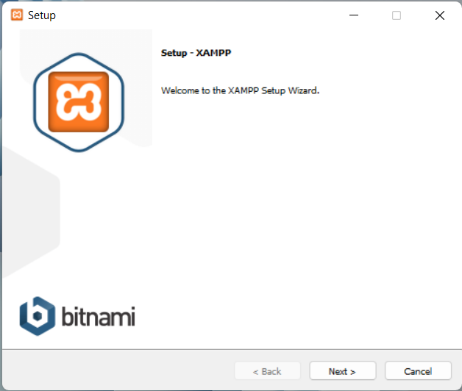

Click

Figure: Step-1

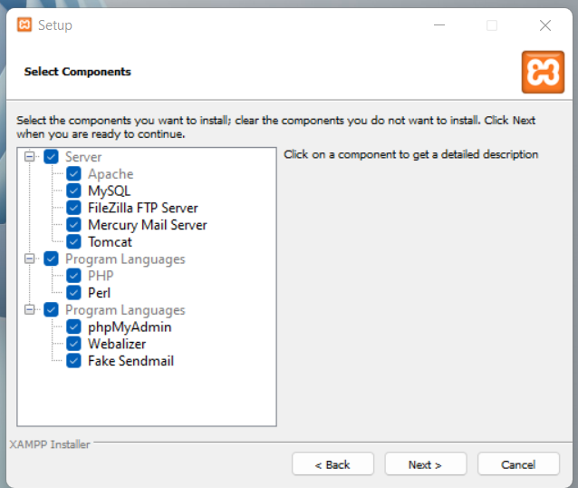

Click

Figure: Step-2

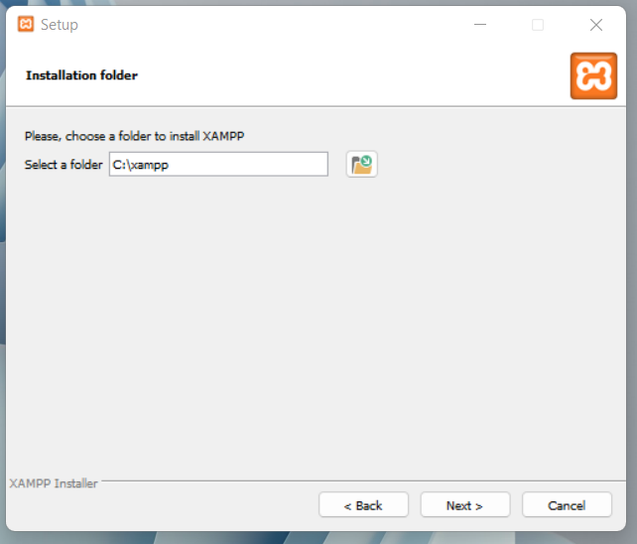

Click

Figure: Step-3

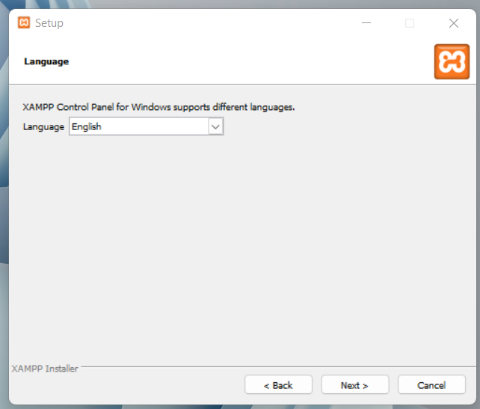

Click

Choose language

Figure: Step-4

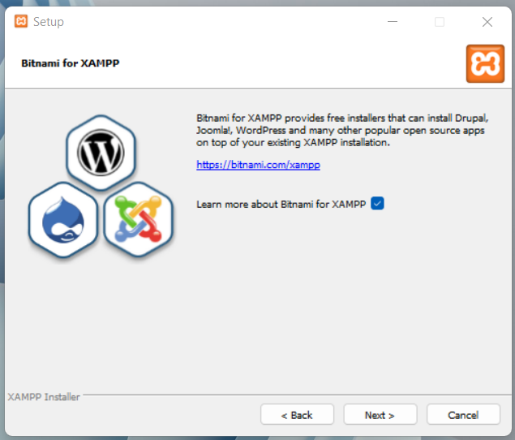

Click

Figure: Step-5

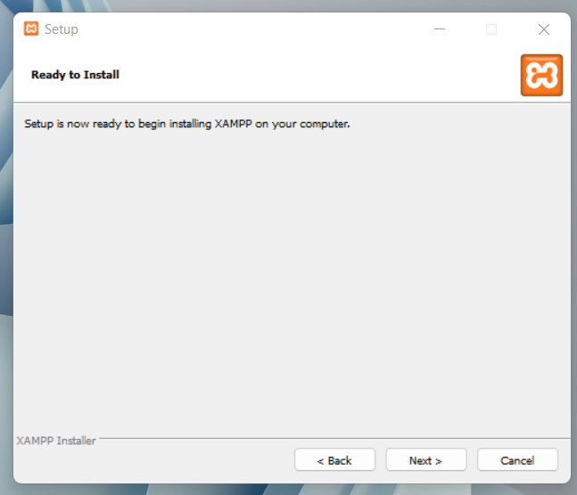

Click

Figure: Step-6

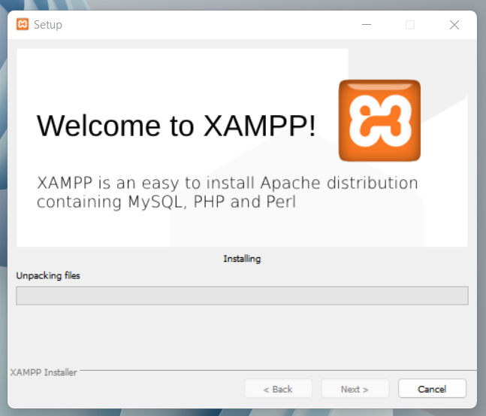

Wait while installing

Figure: Step-7

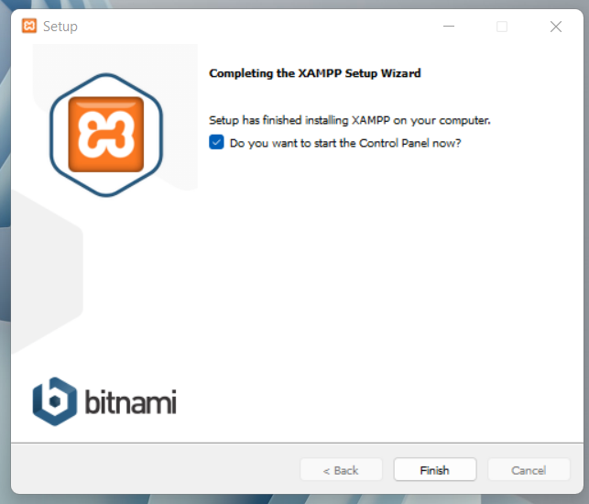

Click

Figure: Step-8

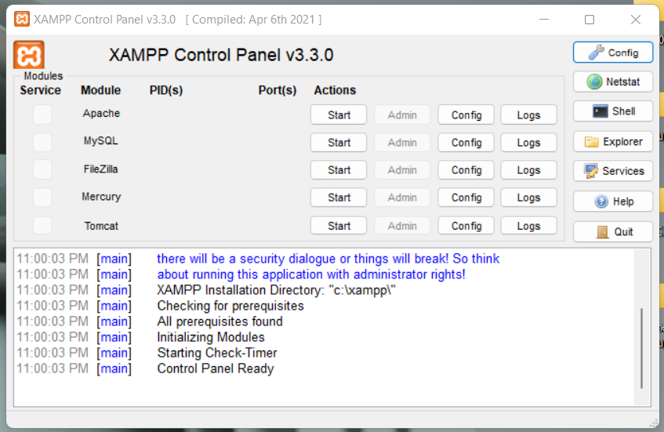

Click MySQL

Start Apache

Figure: Step-9

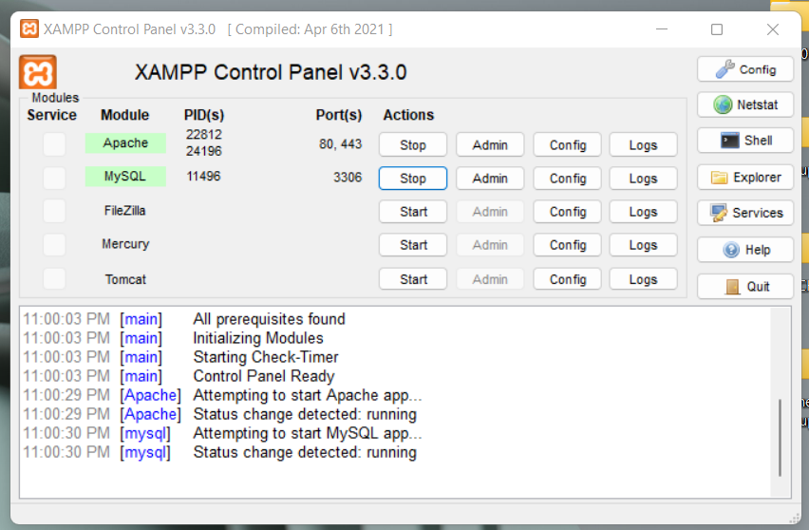

Click

Figure: Step-10

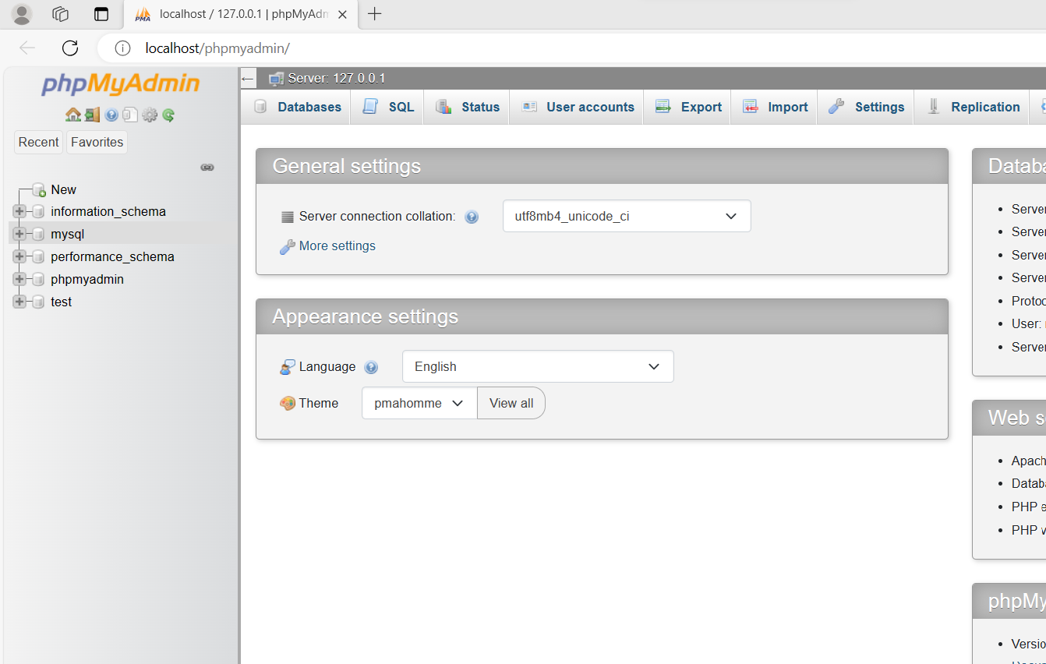

Click to create

new database

Figure: Step-11

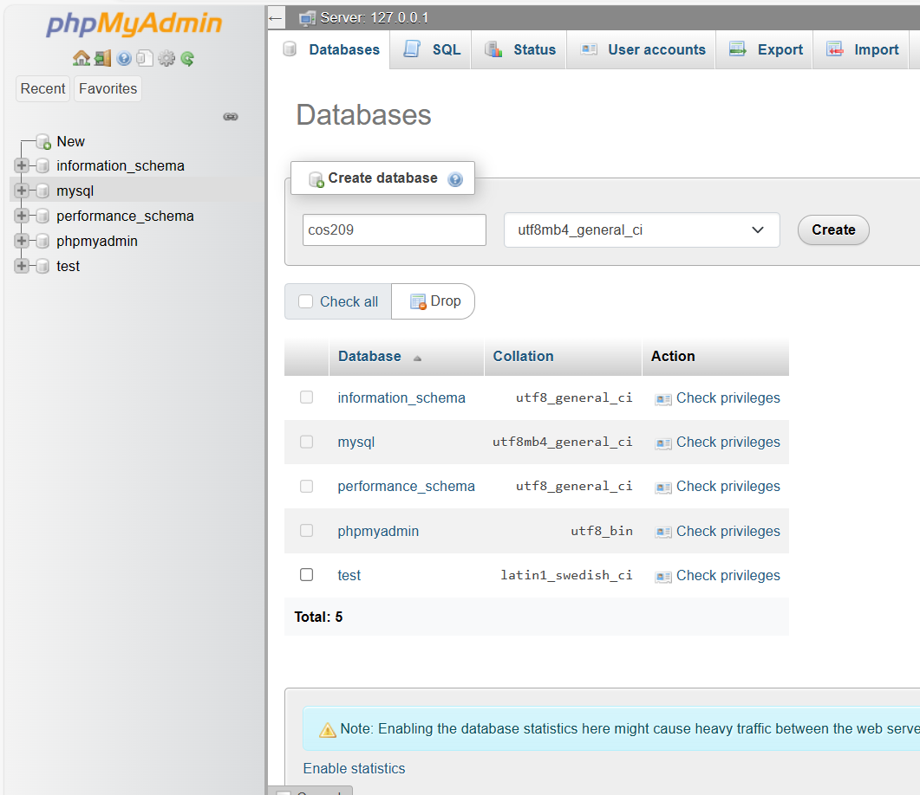

Name “cos209”

Click to create

Figure: Step-12

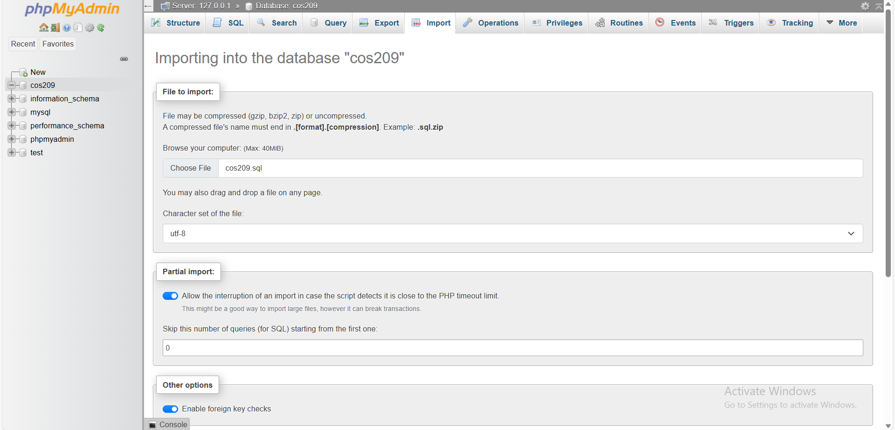

Choose “cos209.sql”

Click

Figure: Step-13

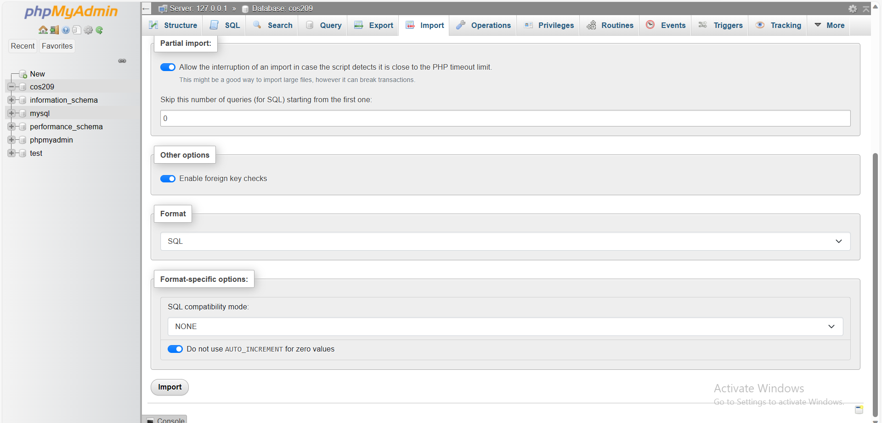

Import

Figure: Step-14

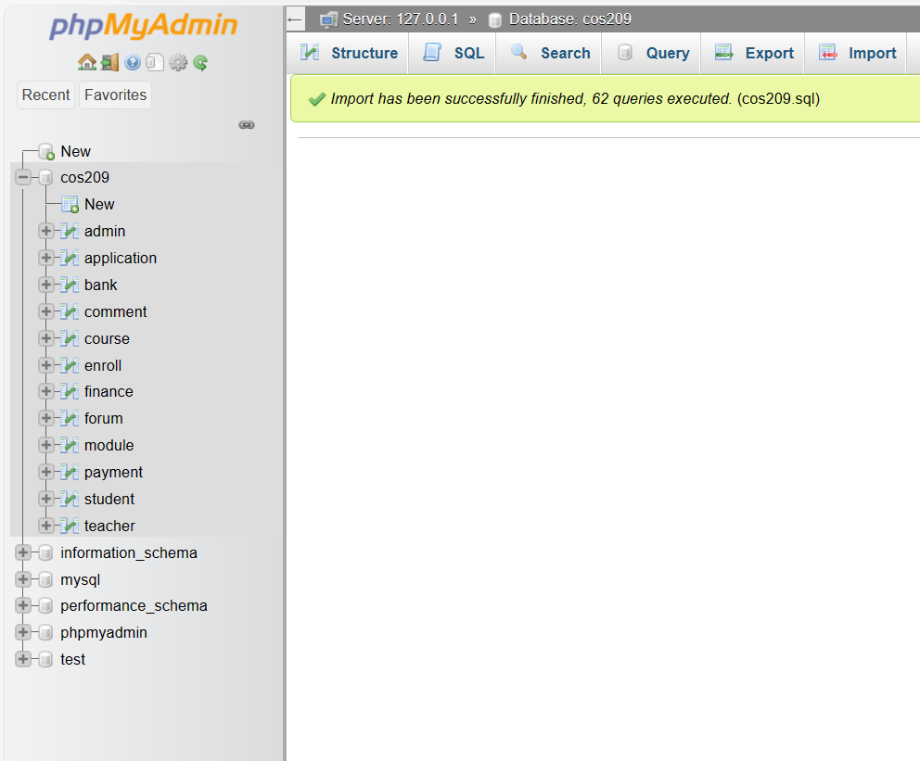

Now you have access to data tables

Figure: Step-15

* Move “COS209” coding file to “C:\xampp\htdocs”.
* Then, you have set up required software and you are now ready to start the system.

## STARTING THE WEBSITE

* Make sure you have opened XAMPP Control Panel and started Apache and MySQL.
* Refer to “Figure: Step-9” of “Installation Guide” if you do not know how to start Apache and MySQL.
* Open internet browser of desired.
* Type in “localhost/COS 209/Home.php” in the omnibox (search bar at the top of browsers).
* Press “Enter” and now you are in the BUC website.

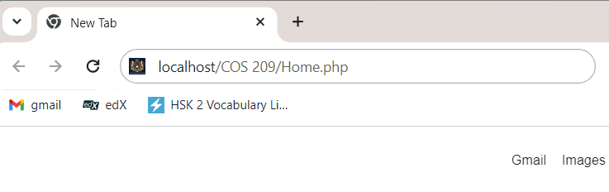

Figure-1: Omnibox of Chrome



Figure-2: Home page of BUC website

## GUIDANCE FOR VISITORS

 Visitors can explore around the website viewing the school information. The main function of visitor is to enroll in a class. The processes of enrolling include filling application form, paying registration fee, checking result and creating account when application gets approved.

To enroll classes



To Refresh Home page

To View About BUC

To Contact BUC

To login and check results

Figure-1: Navigation in Home page



Click to enroll HDB

Click to enroll HDIT

Figure-2: Courses to enroll

1. Fill all the field and check “Terms and Conditions”.
2. Click “Submit” to apply for the selected course.

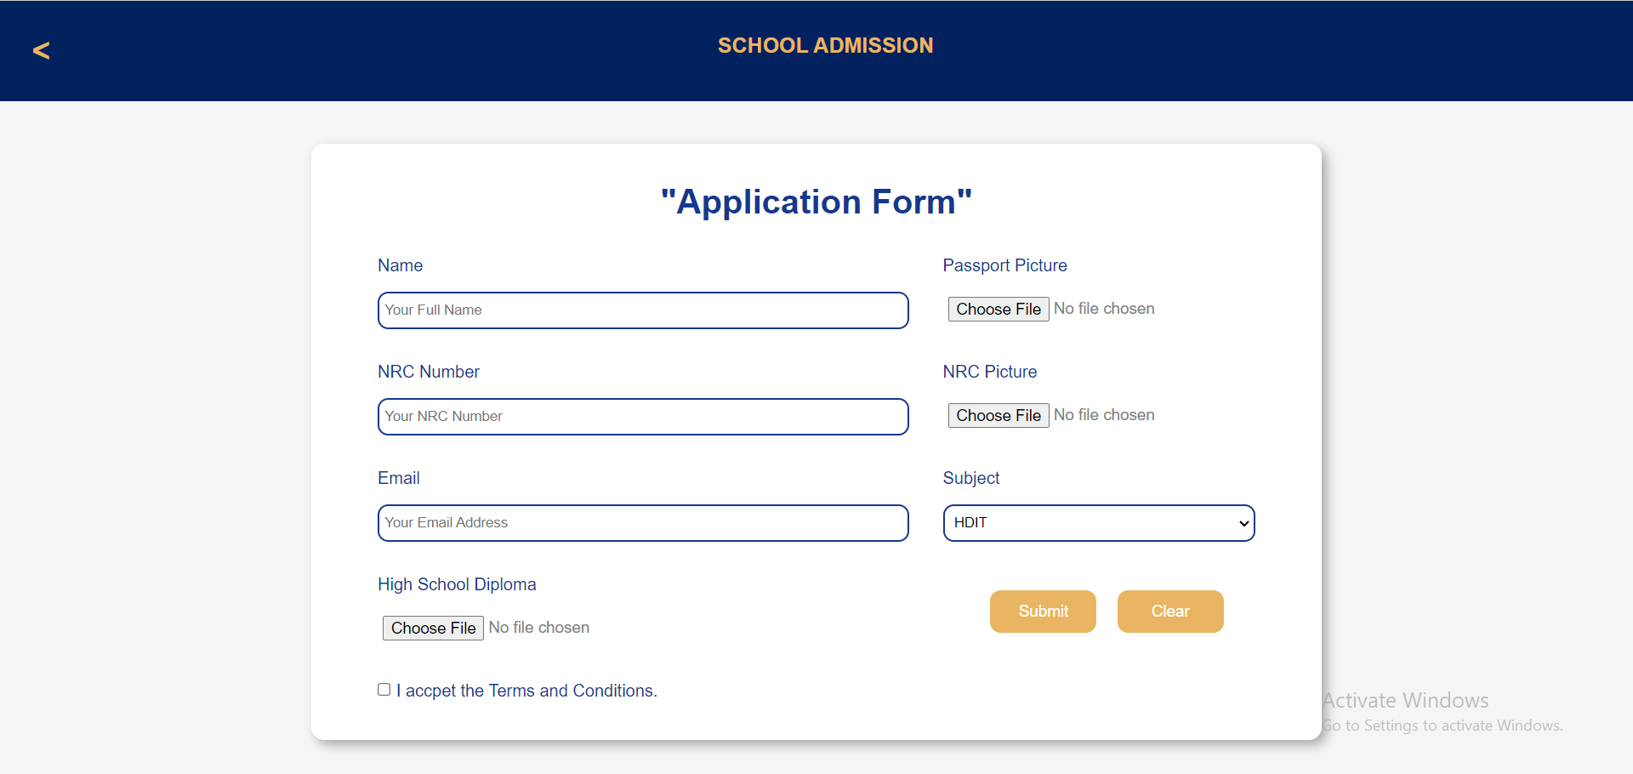

Figure-3: Application Form

1. Select one payment method and fill all the field.
2. Click “Pay” to pay the registration fee.

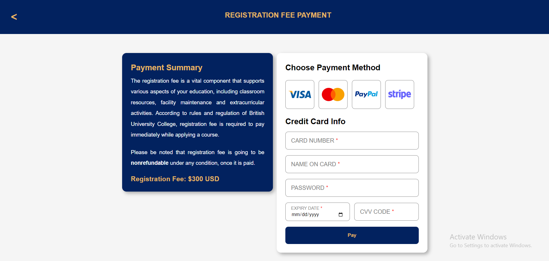

Figure-4: Registration Fee Payment

1. To check the result, click “Login” in the menu bar of the home page.
2. Click “Here” at the bottom of the display.

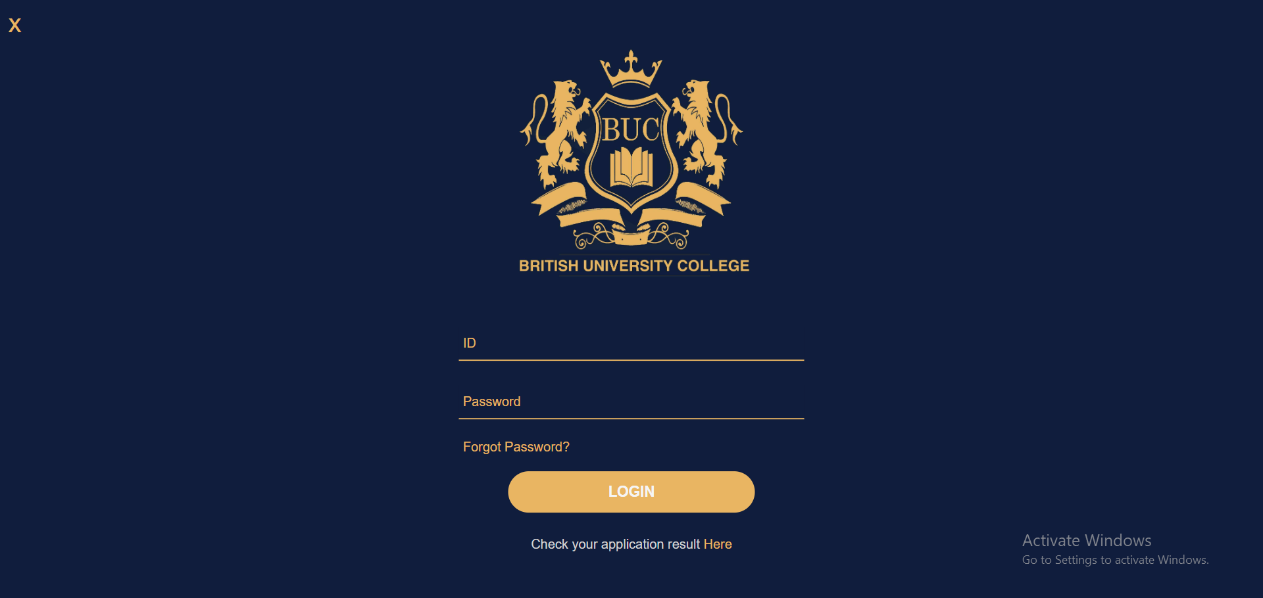

Go back

Click to check result

Figure-5: Login Form

1. Click “Here” in the result text.
2. Remember that applicant can create account if only approved by admin.

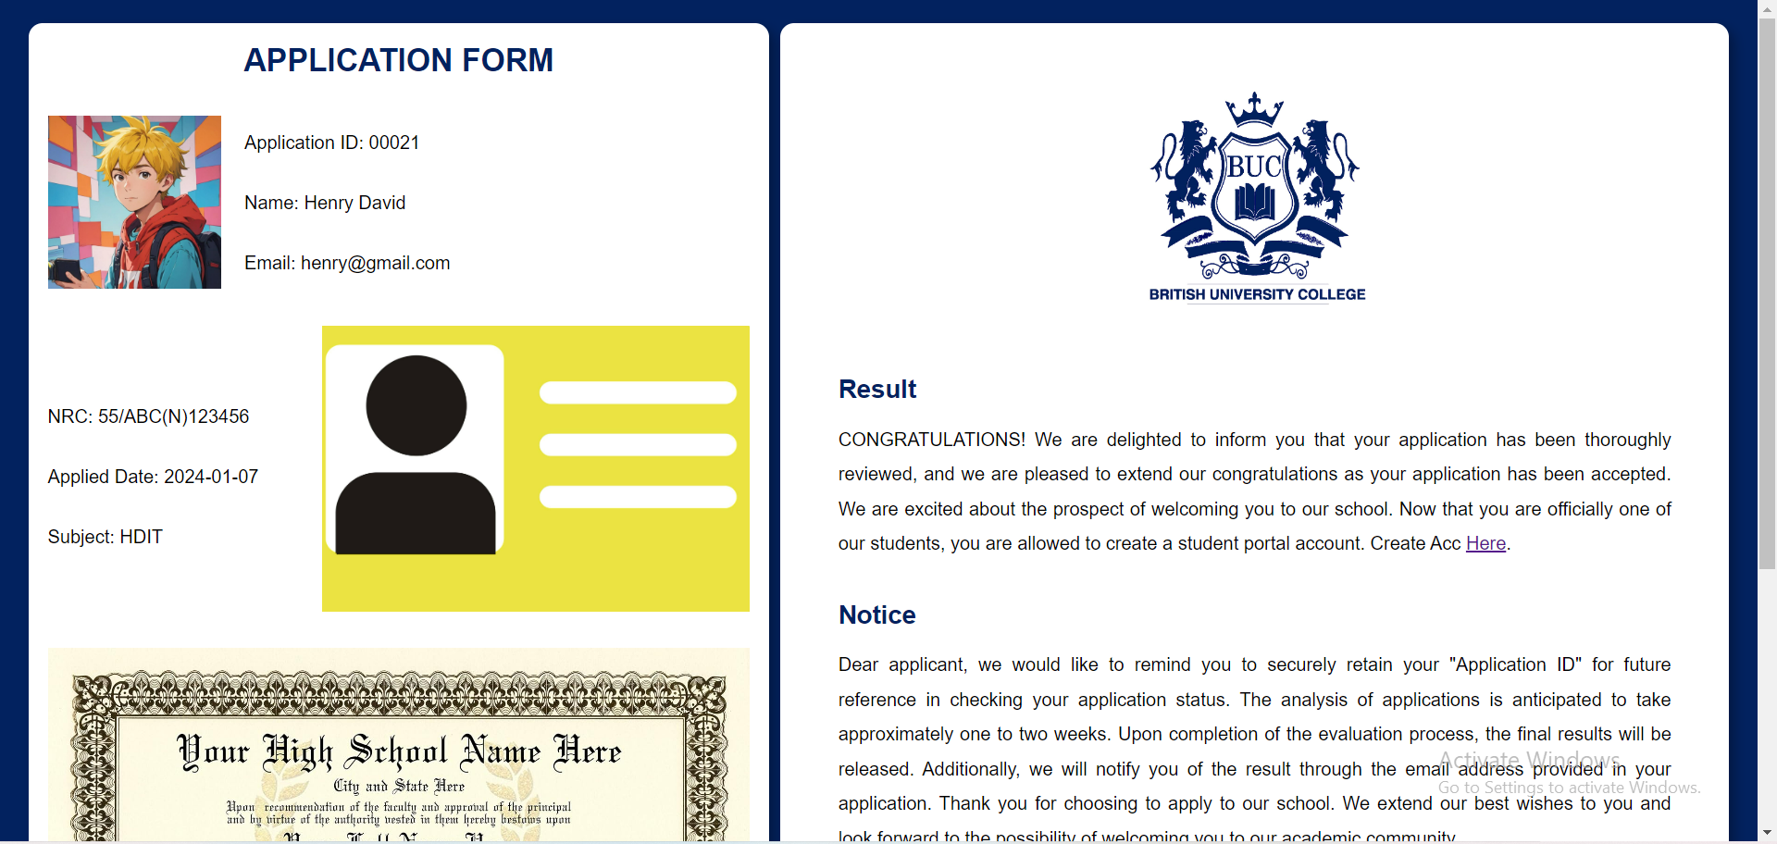

Click

Figure-6: Result page

1. Fill all the field with your personal information.
2. Set a password of at least “8” letter length and confirm it again.
3. Press “Sign Up” button to confirm creating your student portal account.

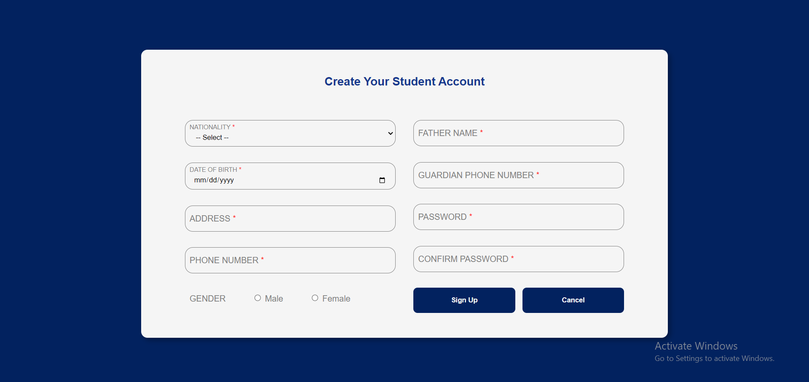

Figure-7: Sign Up form

## GUIDANCE FOR STUDENTS

Students of BUC have permission to edit their own personal data, view and give payments, and enroll in new class. They can also access to student forum where they can post and comment. To be able to do so, every student has to login.

1. Fill your ID and Password in respect fields.
2. Enter “Login” button.



Figure-1: Logging into student portal

1. Select “Edit Profile Information” to change your personal information.
2. Once you go into webpage, your data can be seen.
3. Change the data as you wish without any empty field.

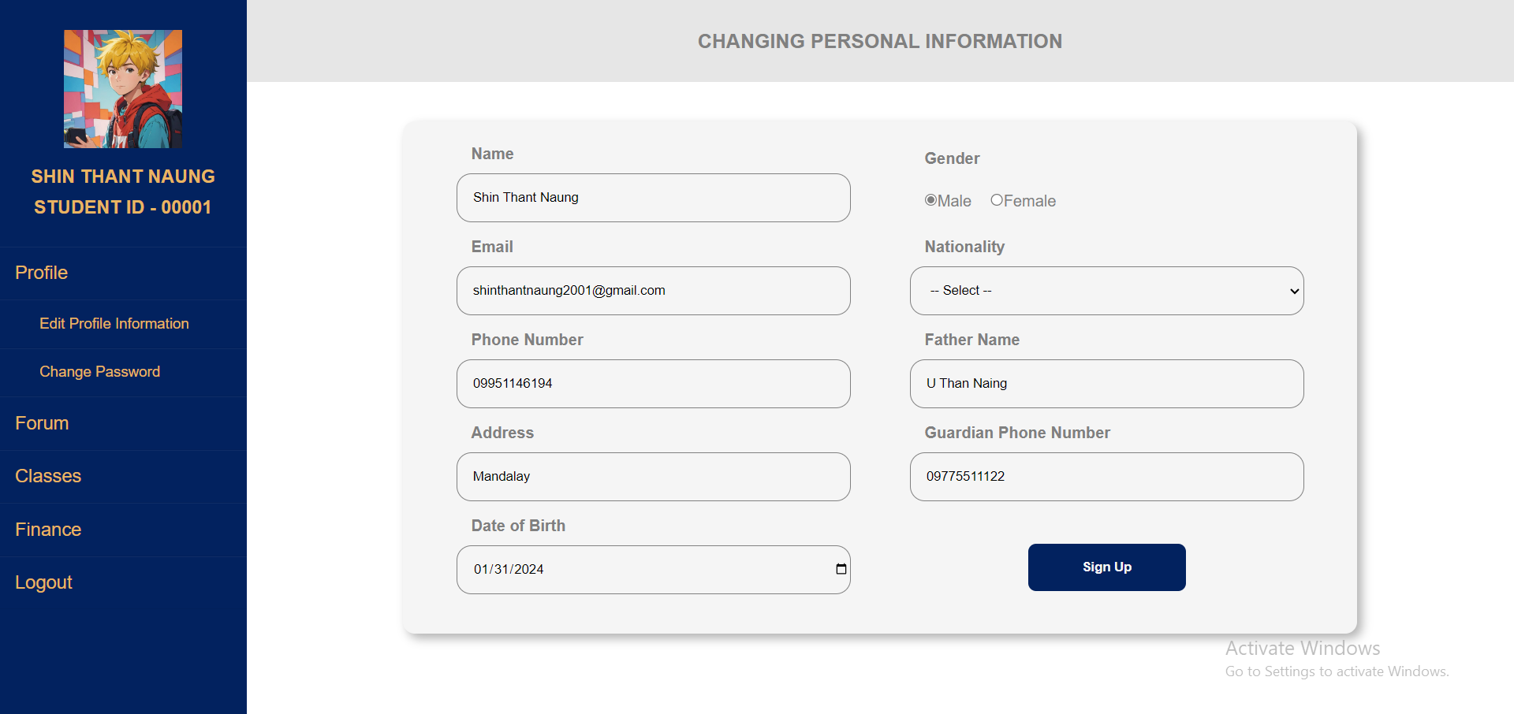

3

2

1

Figure-2: Changing personal information

1. Select “Change Password” in side menu bar.
2. Enter your current password.
3. Set a new password of at least 8 letter length.
4. Confirm the password again.
5. Press “Confirm” to change.

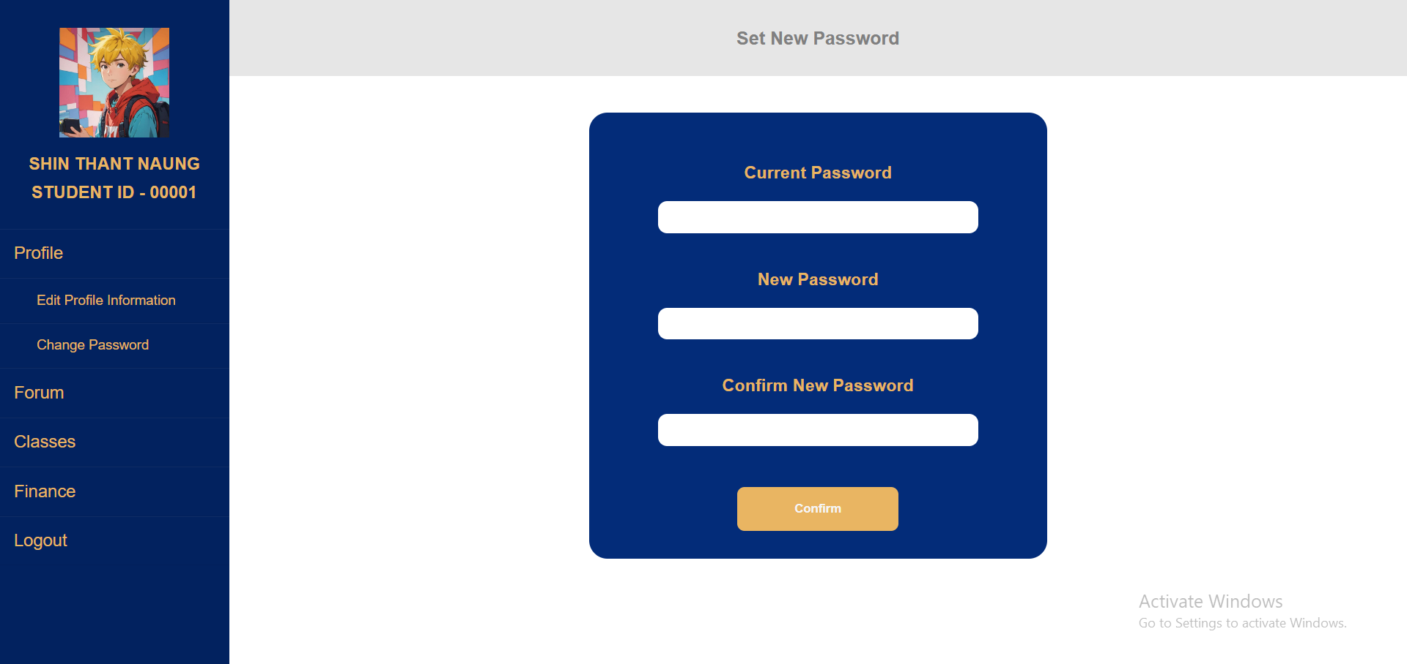

5

4

3

2

1

Figure-3: Changing password

1. To add comment to a post of student forum, select “Forum” on the side menu bar.
2. Click the “comment” button on the post you want to add comment on.
3. Fill the field with what you want to say.
4. Click “Comment” to finally leave a comment on post.

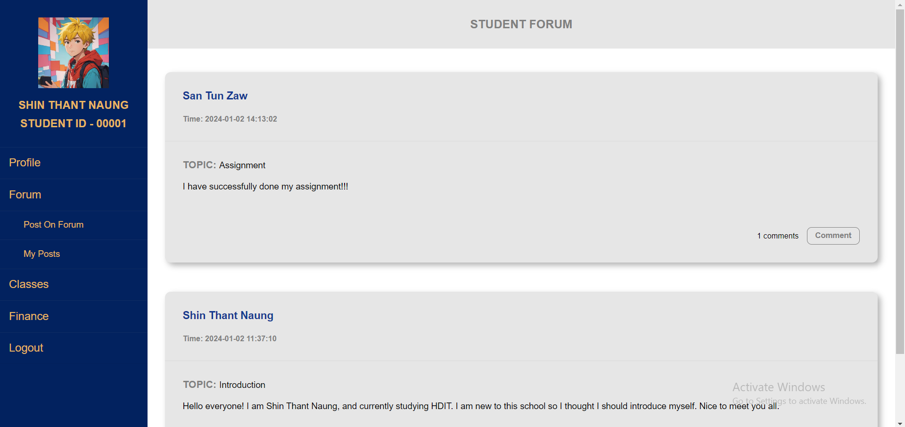

2

1

Figure-4: Commenting on a post

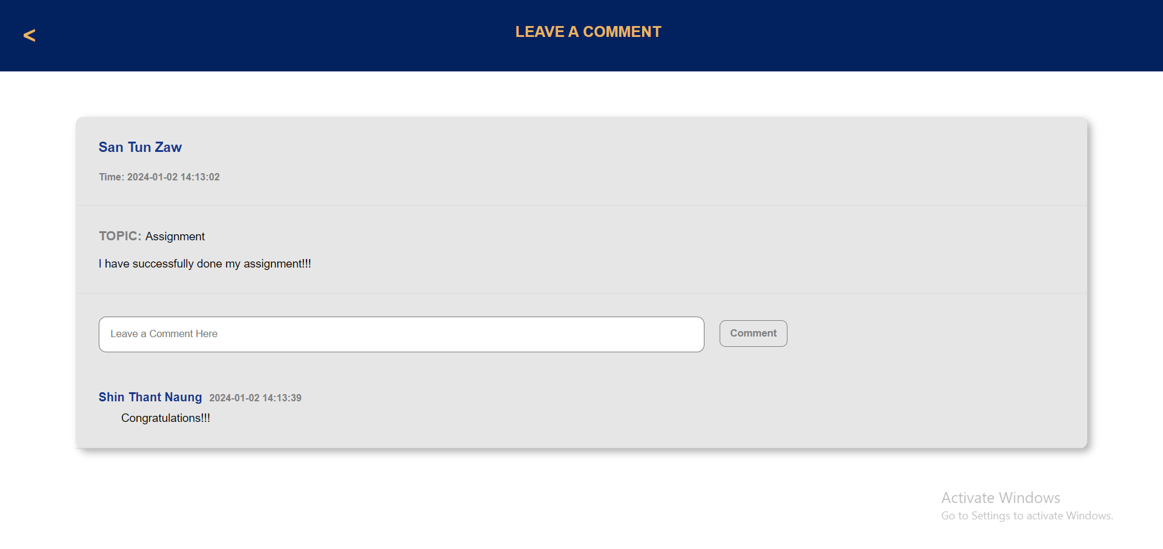

4

3

Figure-5: Commenting on a post

1. To add a new post on forum, select “Post on Forum” on the side menu bar.
2. Fill all the field on the form appeared.
3. Click “Upload” to finish posting.



1

Figure-6: Adding a new post on forum

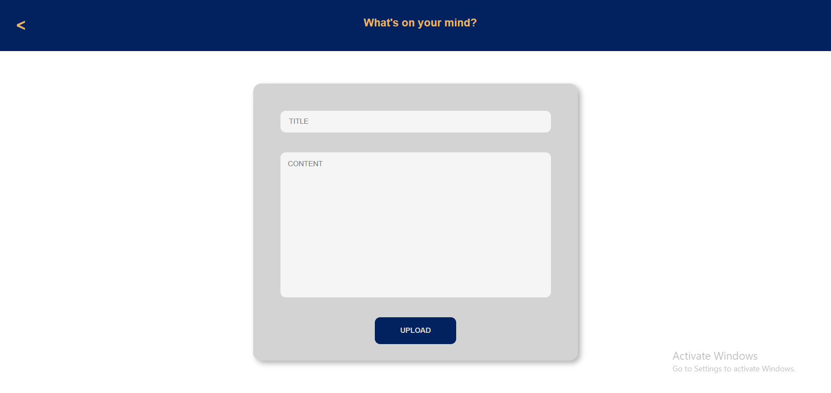

3

2

Figure-7: Adding a new post on forum

* As a student of BUC, you have privilege to enroll a new course without needing to pay for registration fee and filling forms again.
* Select “Classes” on the side menu bar of your student portal.
* Scroll down to the webpage, select your desired course, and you are enrolled.
* Remember that you cannot enroll the class you are already studying in.

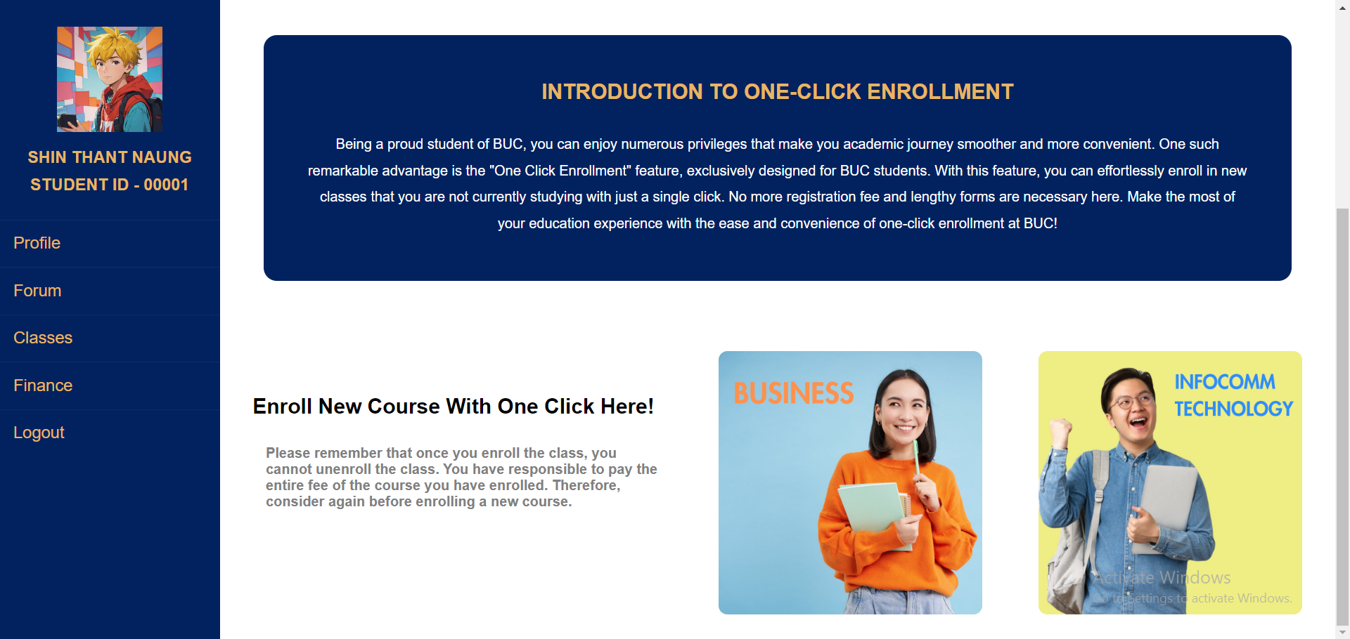

Click

Click this for HDB

Click this for HDIT

Figure-8: Enrolling new class

1. For paying your school fee, select “Finance” on the side menu bar.
2. Choose the course you want to pay fee for.
3. If you are paying for the first time of the course you have selected, choose an installment plan and press “Okay”.
4. Fill all the fields with you bank card information.
5. Click “Pay” to confirm your school fee payment.

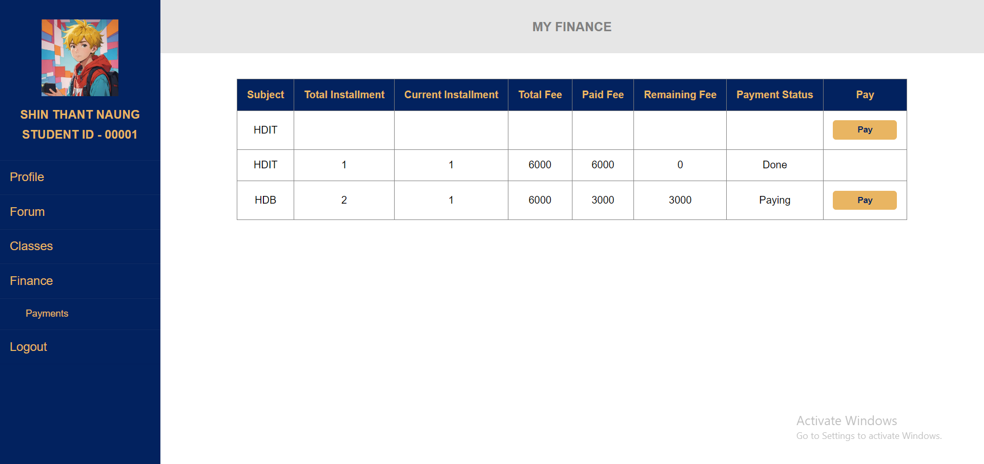

2

1

Figure-9: Paying school fee

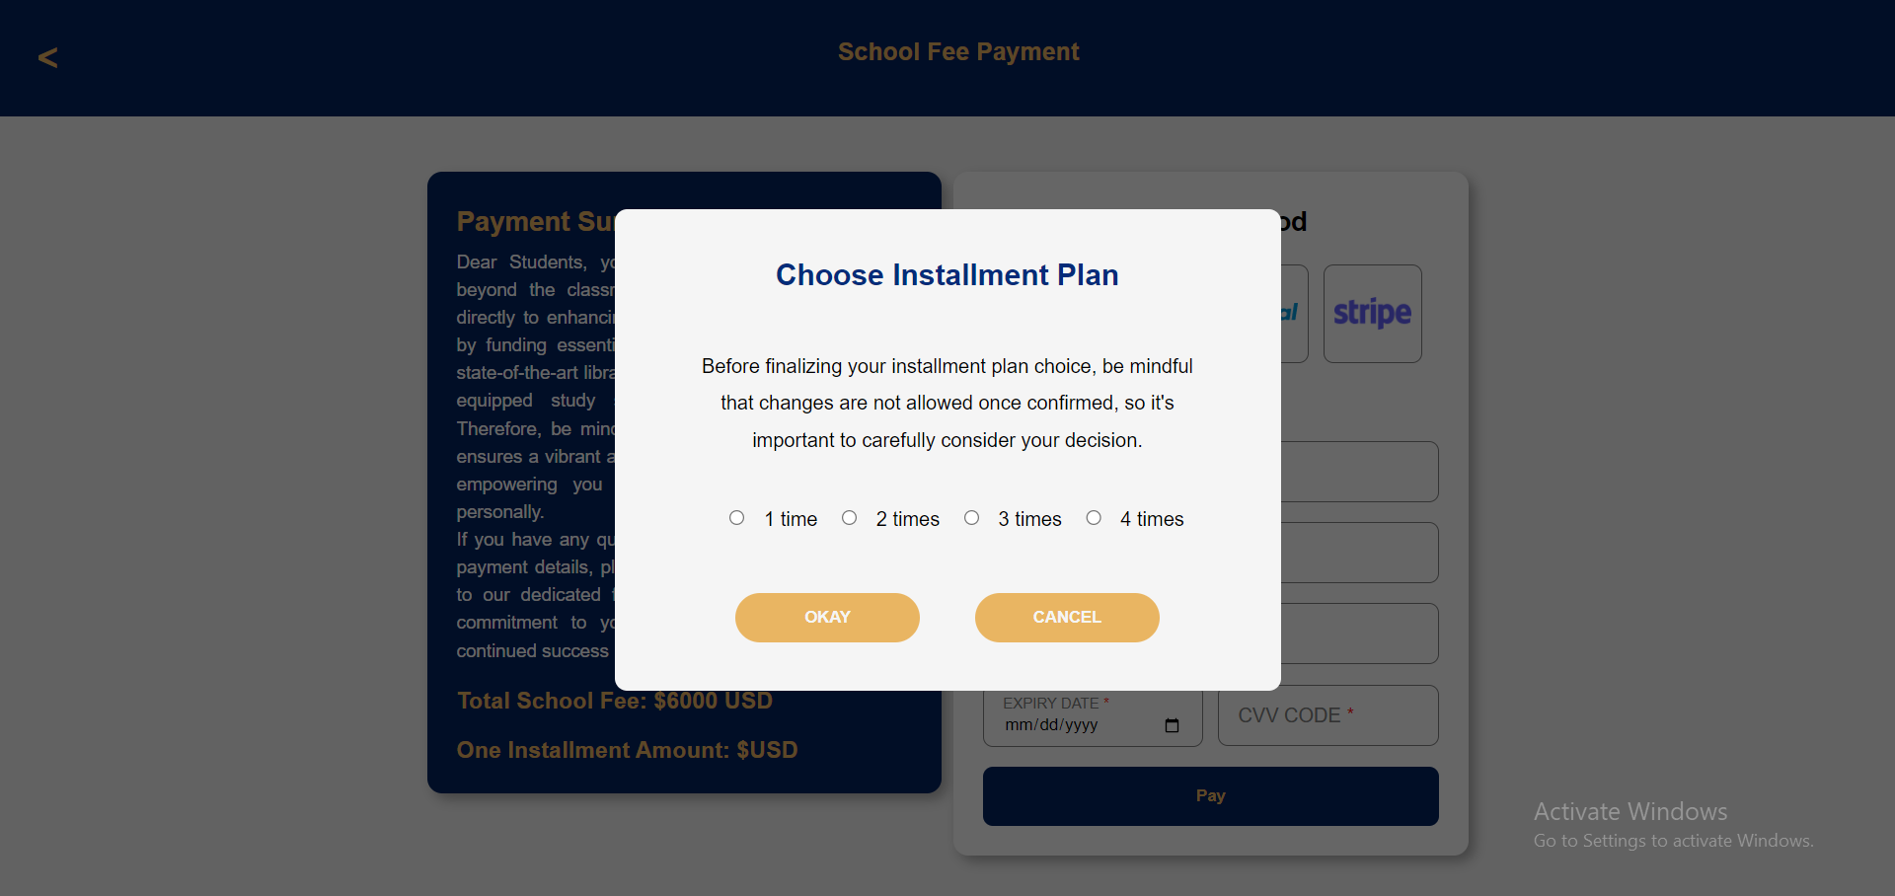

3

Figure-10: Choosing installment plan

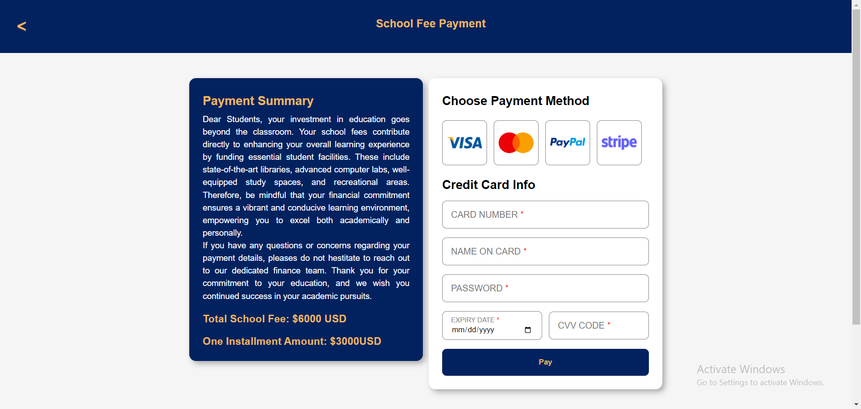

5

4

Figure-11: Paying school fee

1. To view the receipt of your payments, select “Payments” on the side menu bar.
2. Choose the payment you want to see receipt of.
3. The receipt will be shown in new webpage.
4. Click “OK” or the back button on the top menu bar to stop looking at receipt and go back to the student portal.

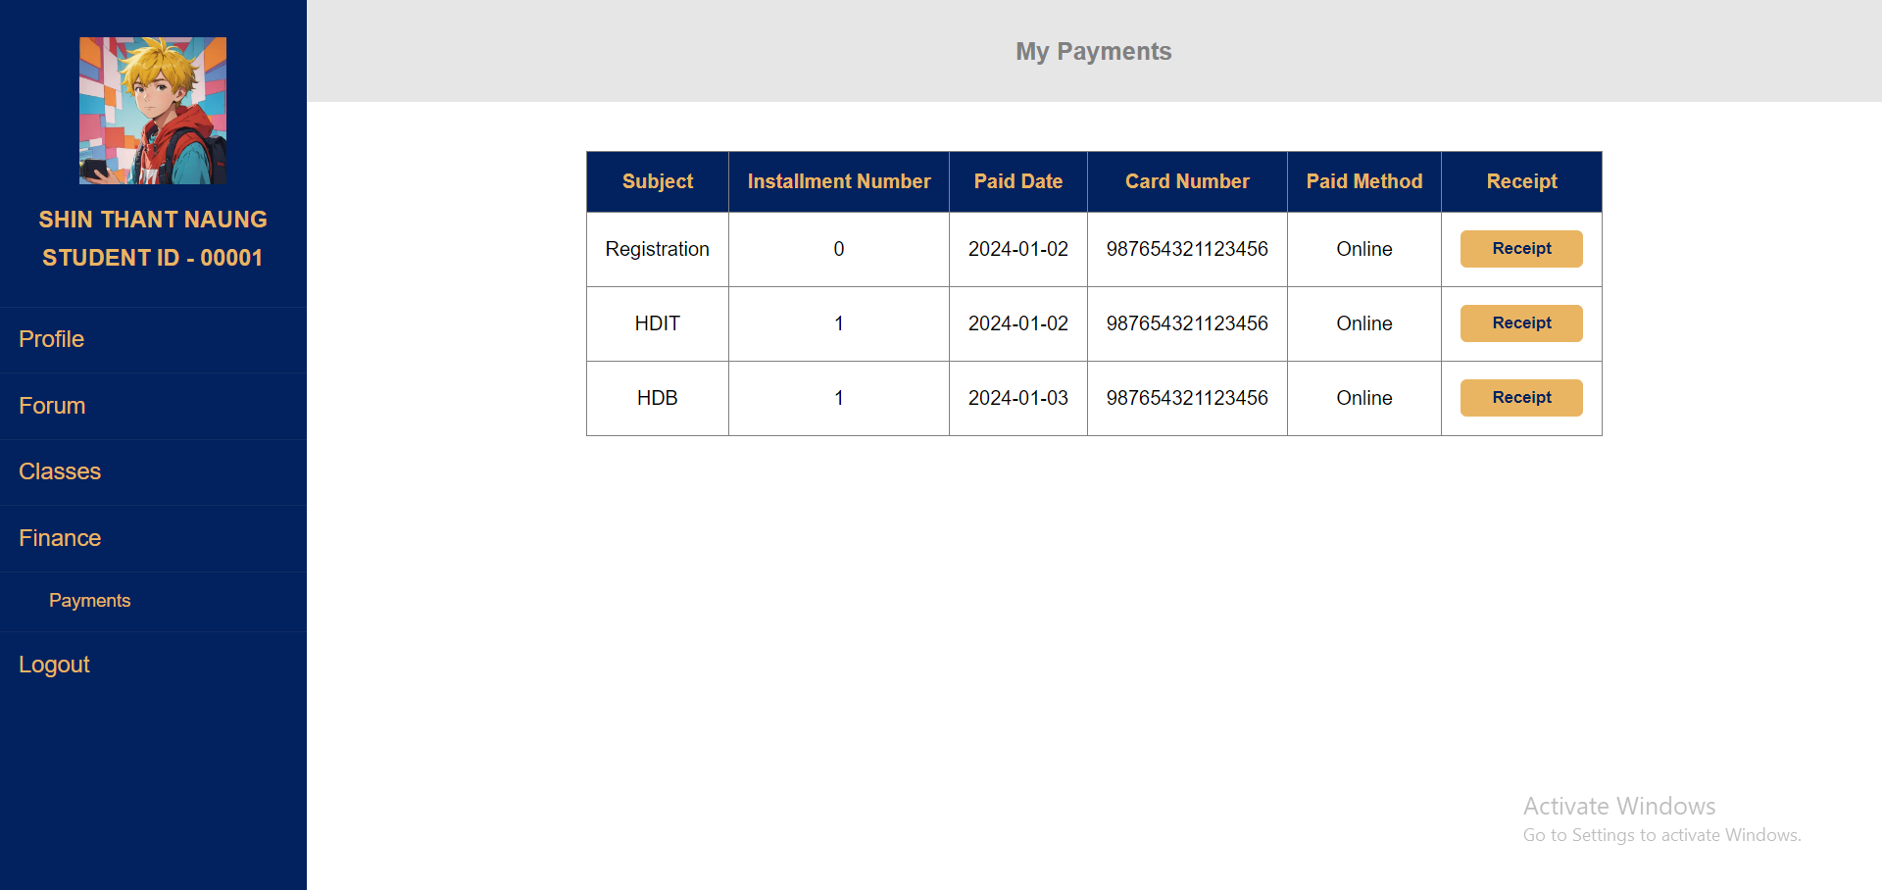

2

1

Figure-12: Viewing receipt

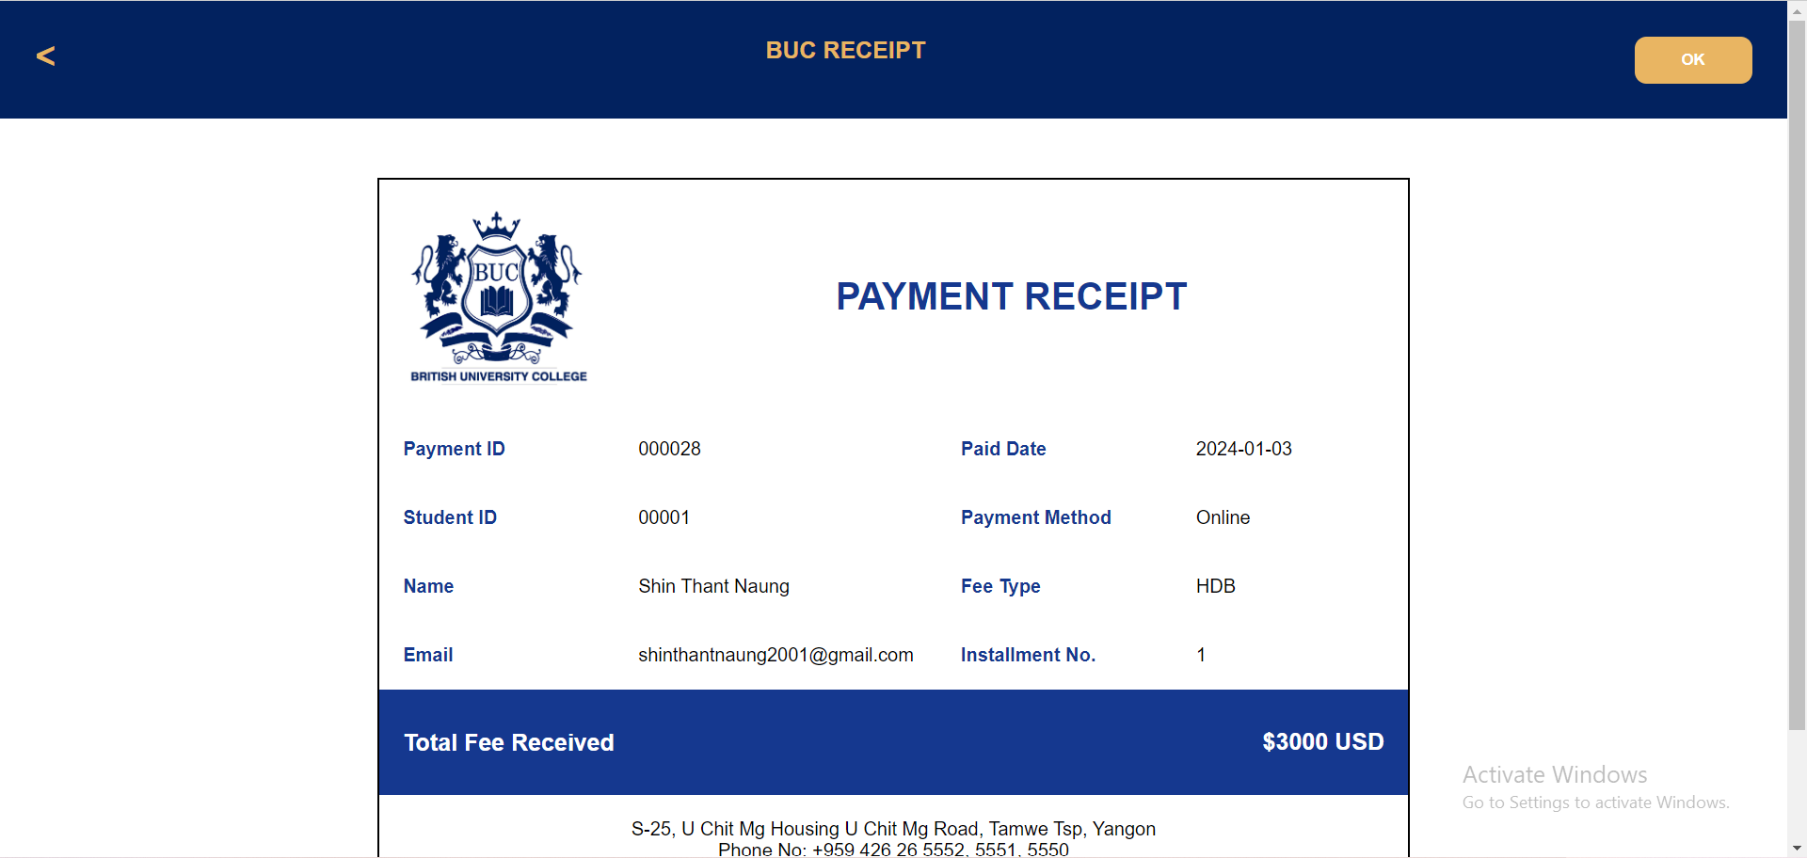

Click to go back

Click to go back

Figure-13: Viewing receipt

## GUIDANCE FOR ADMINS

The admins of BUC have different types of functions that they can perform. Every staff of different positions and departments has to login to get into the admin webpage. The different functions of BUC admin teams are as follow with step-by-step manuals.

The staffs of certain positions such as junior and senior finance staffs, and staff of student support team can see all the registration fees and school fees done, and view receipt of it.

1. Select payment type in radio button and click “Okay”.
2. Choose the payment you want to see receipt of, and press “Receipt” button.

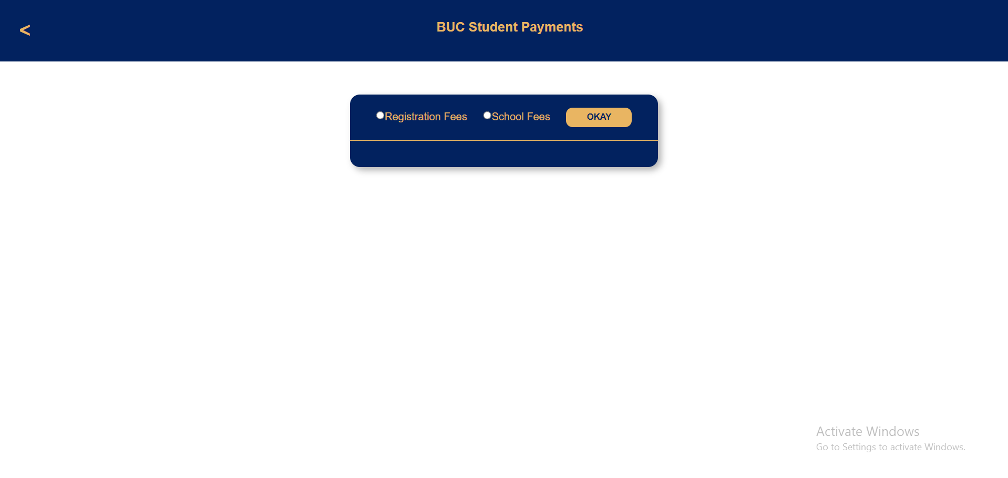

1

Figure-1: Selecting payments

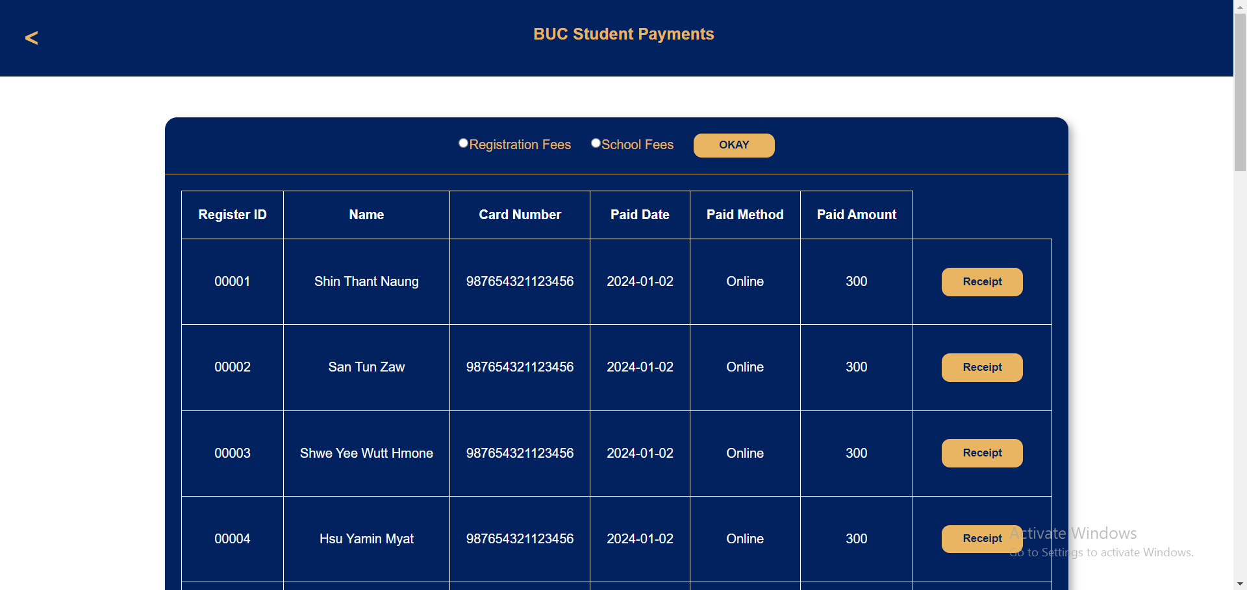

2

Figure-2: Viewing receipt

Most finance staffs have access to search payments by application ID or student ID, and then give out the receipt.

1. Select the ID you want to search with. To see registration fees, choose application ID and otherwise if you want to see student ID.
2. Fill the field with application ID or student ID.
3. Press “Search” button to see the list of payments.
4. Select and click “Receipt” button to view the receipt of the payment.

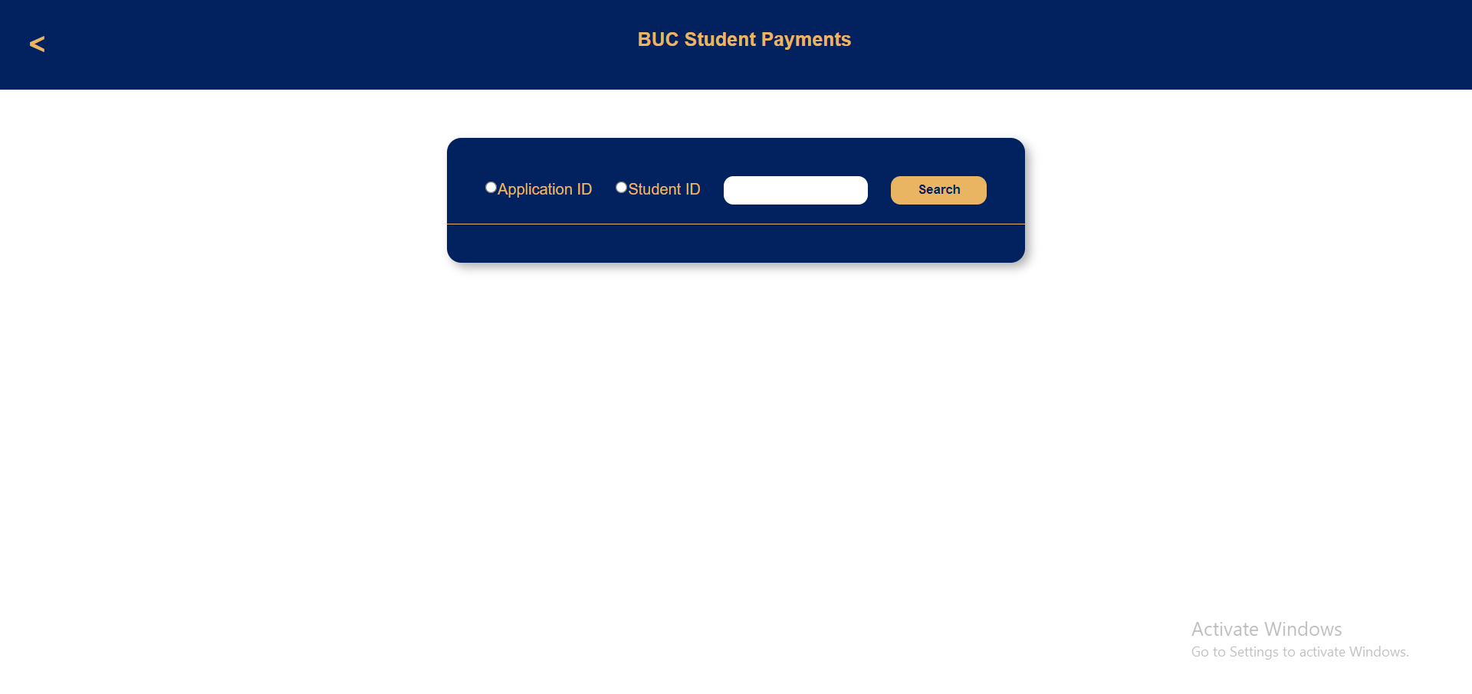

1

3

2

Figure-3: Searching payments by IDs

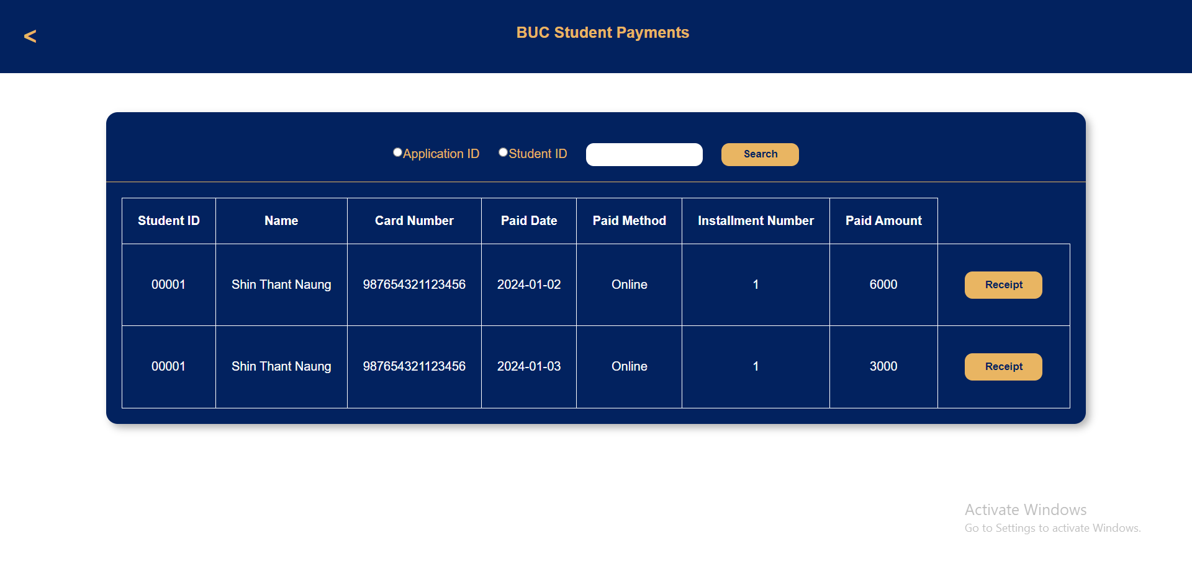

4

Figure-4: Viewing receipt

Senior Finance staffs also have permission to change the status of a student payment for enrollments. The table shows total fee student has to pay and the fee student has done. If the total fee and paid fee are the same, the staff has to click “Change” button to make the status as “Done” marking that the student has fully paid for an enrollment.

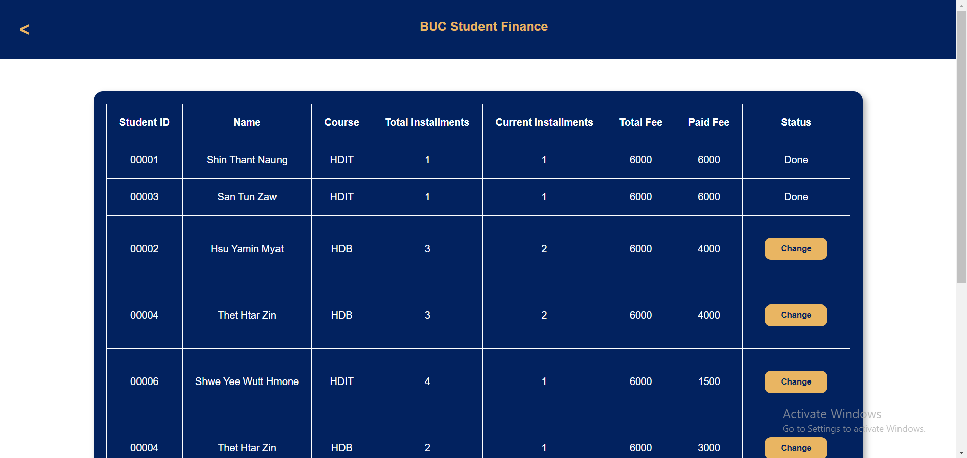

Click

Figure-5: Changing status of student finance

Senior Finance admins are also capable of receiving the student fee in cash on campus.

1. Ask the student ID of the payer, and fill the field.
2. Click “Select” to see the list of enrollments the student has done.
3. Ask the student what payment is wanted to done, and select the “Receive” button of the desired payment.



2

1

Figure-6: Searching student by ID

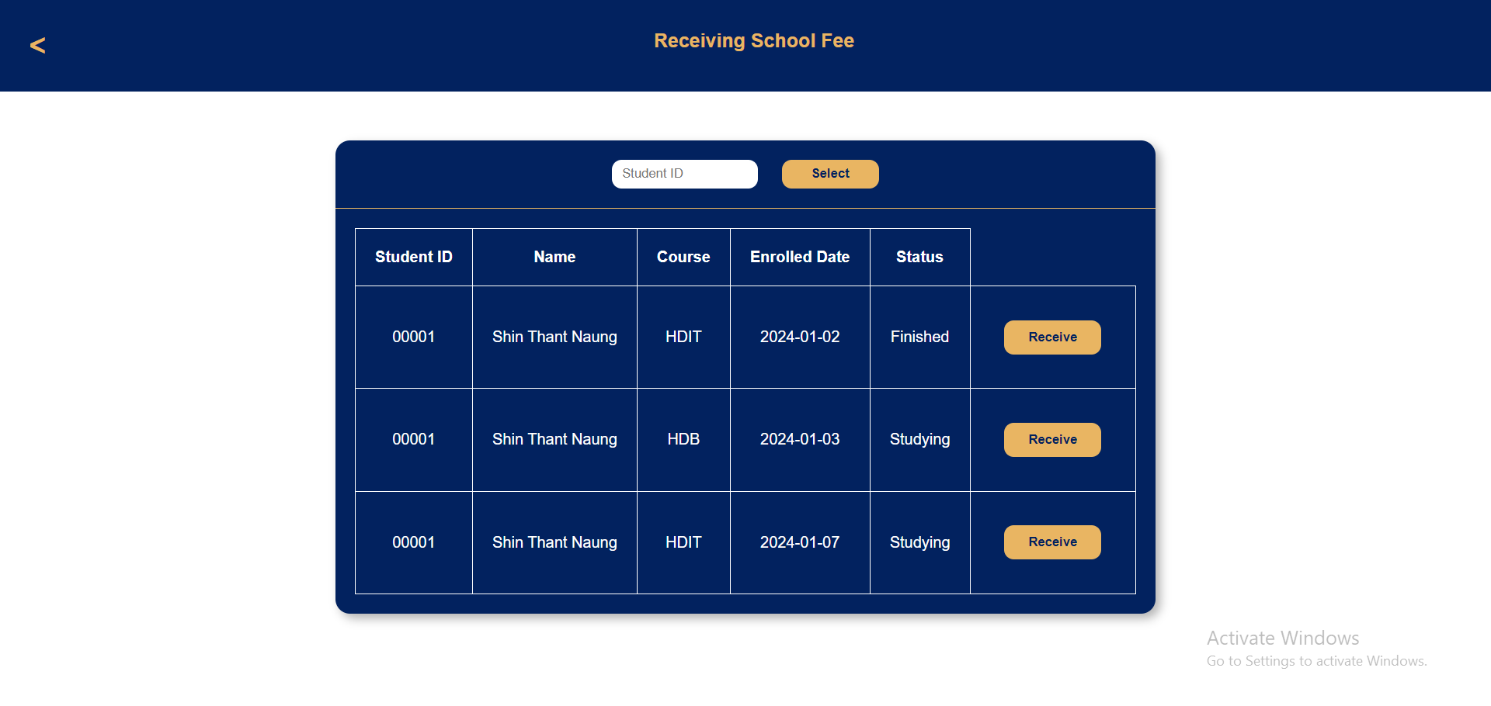

3

Figure-7: Selecting the enrollment to receive school fee

1. Confirm the installment plan from the student and select the plan on the system.
2. Choose the payment method.
3. Fill all the bank card information of student
4. Click “Pay” to receive the school fee.



4

Figure-8: Choosing installment plan

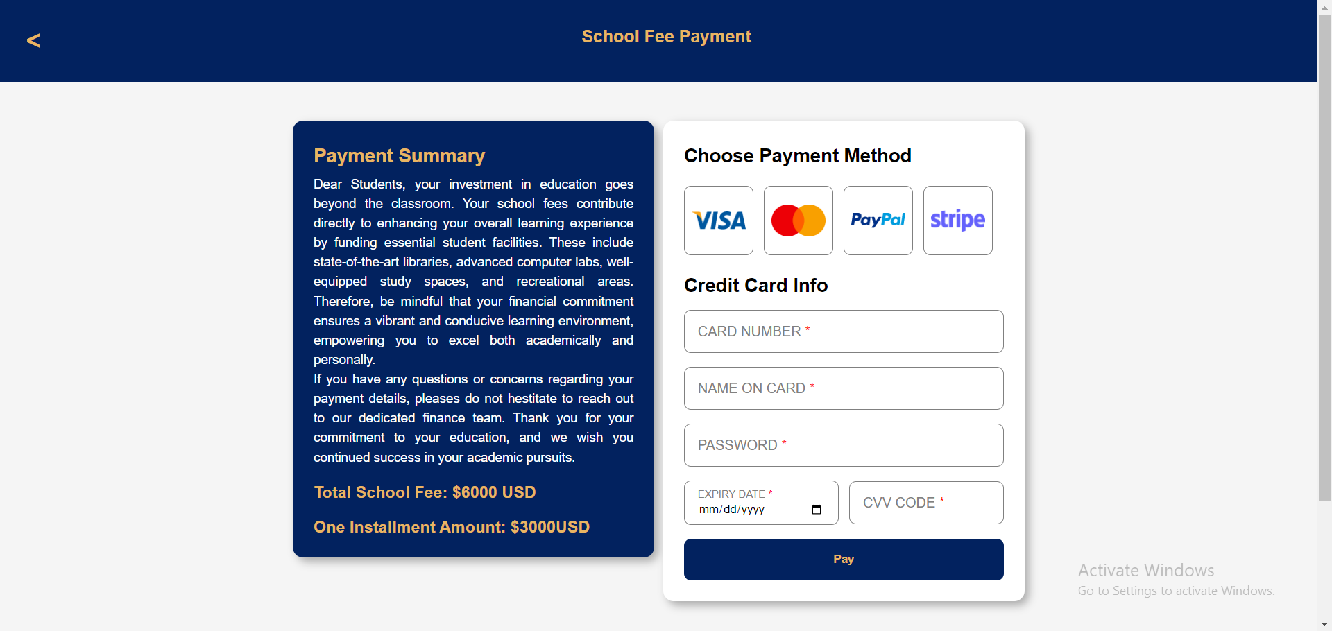

7

6

5

Figure-9: Receiving the payment

Certain Student Service staffs can see list of applicants and students. To do so, you have to choose which list you want to see in the box above. The table of list of either applicants or students will appear as your choice.

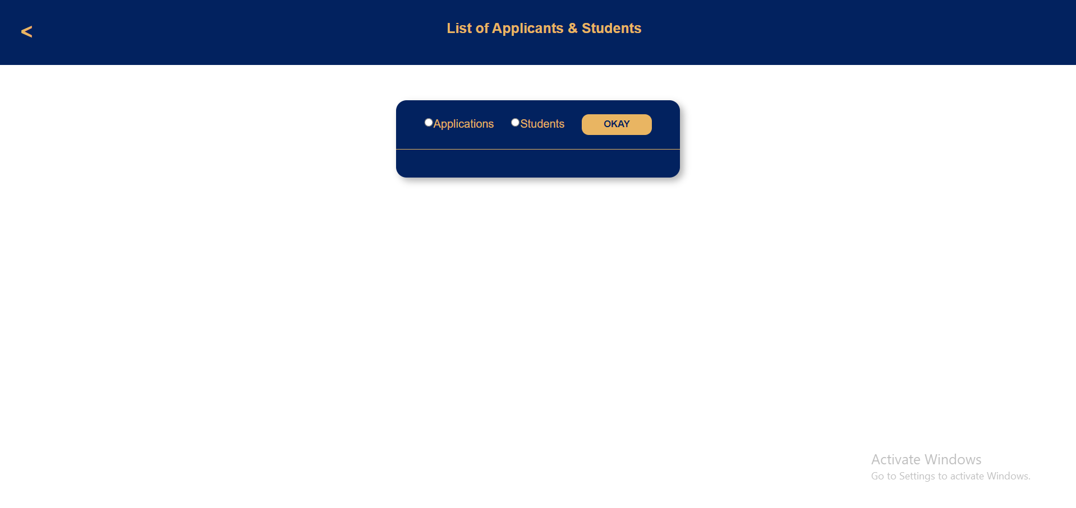

Click

Select what you want to view

Figure-10: Selecting list of applicants or students to view

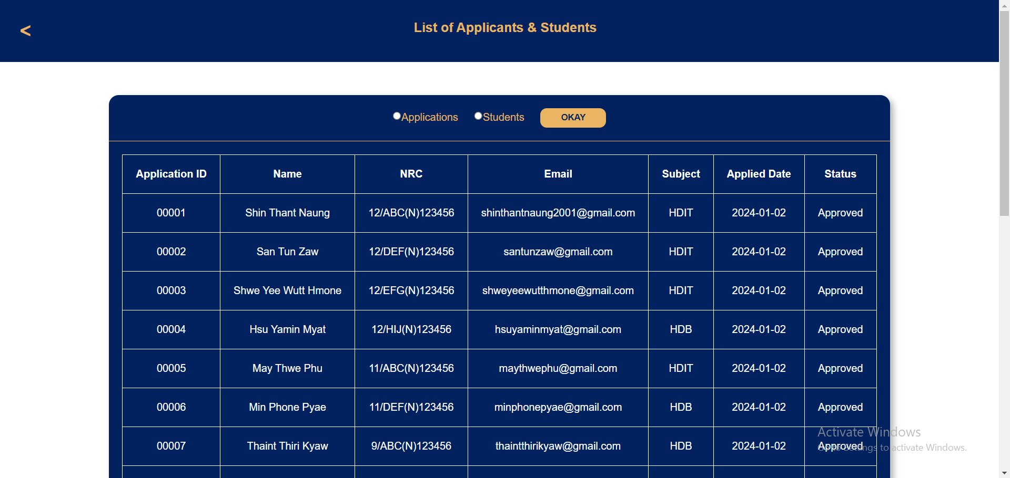

View table

Figure-11: Viewing list of applicants or students

Student information can be edited by the administration staffs of certain Student Service department positions.

1. Type in the ID of the student whose information you want to change.
2. Click “Search” button to go to the webpage of editing form with filled information of the searched student ID.
3. Update the information of desire.
4. Press “Update” button to confirm editing student data.



2

1

Figure-12: Searching student by ID

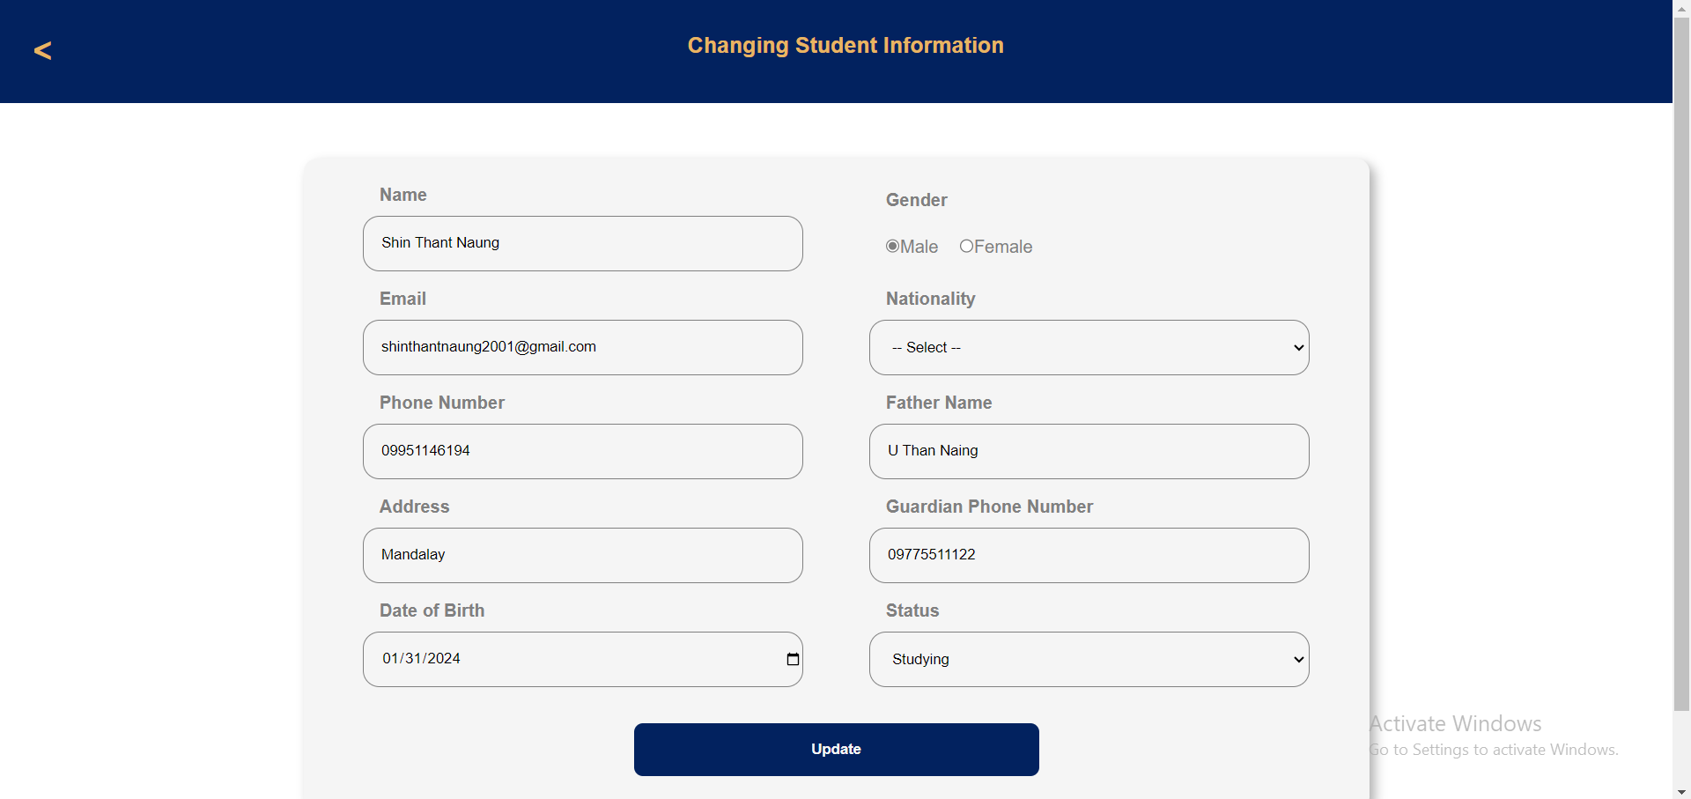

4

3

Figure-13: Changing student information

Manager of Student Service department has ability to reject or approve the applicants by deciding on the application form. To do so, you have to make decision by looking at the application form on the list and click either “Approve” or “Reject”.

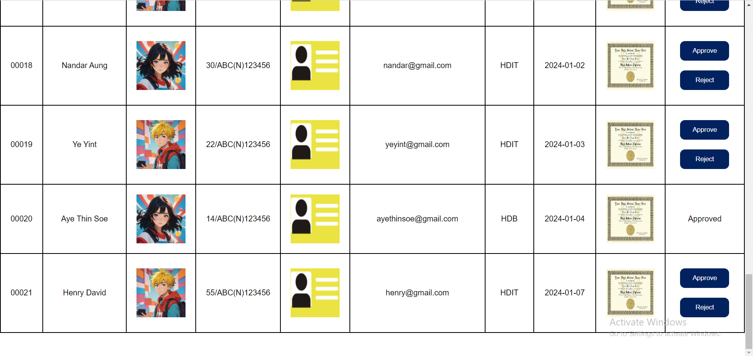

Click to reject

Click to approve

Make decision by looking at application

Figure-14: Deciding the application

Student Service Manager can also make decision on a student’s failing or finishing a course. To do so,

1. Choose the course you want to see student list of.
2. Click “Okay” button and the student list of selected course will appear.
3. Make decision by clicking “Fail” or “Finish” button.



2

1

Figure-15: Selecting course to view student list

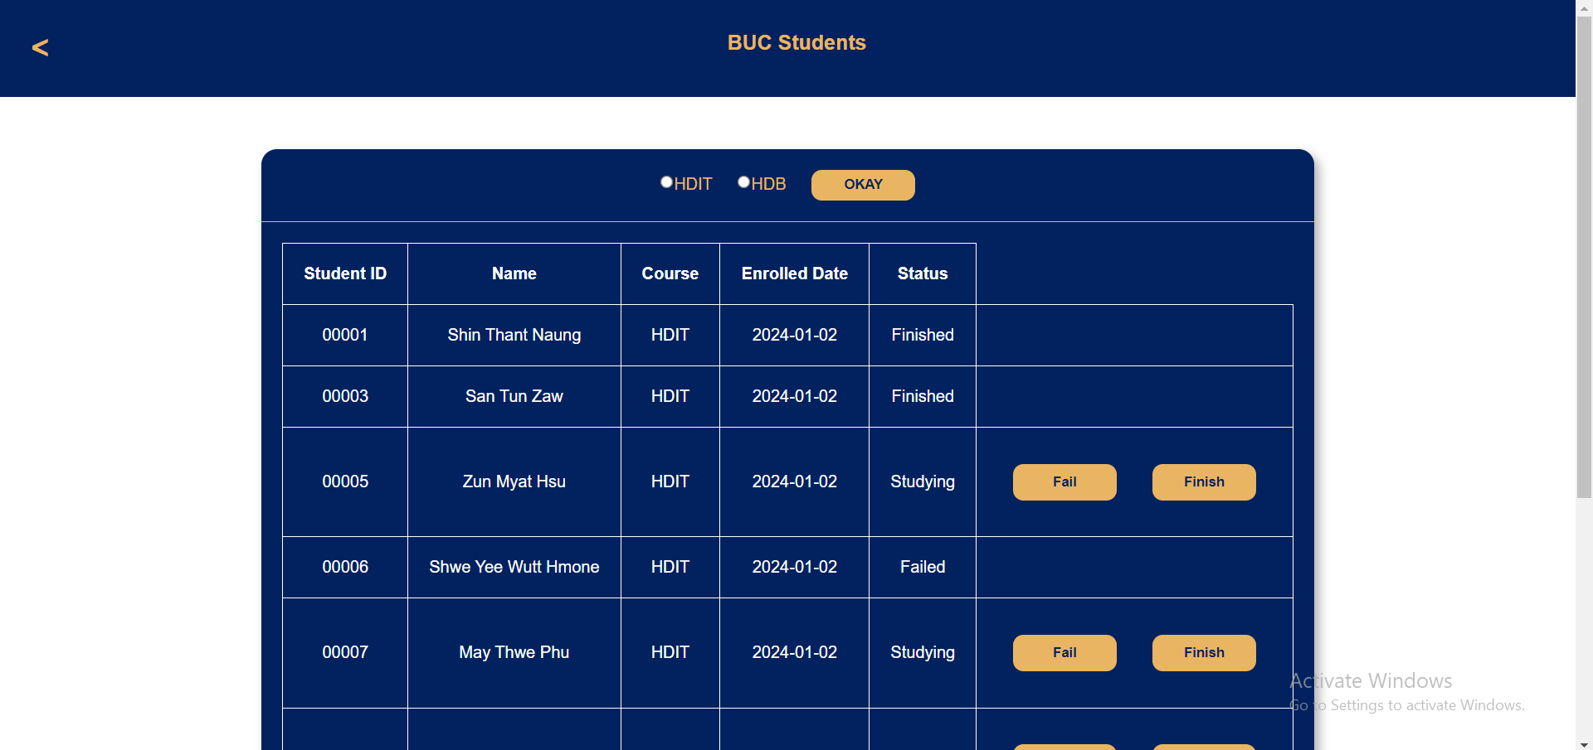

3

Figure-16: Making decision of student status

Student Support staff can see the student forum posts to investigate if they are violating rules and regulation online. If any inappropriate post is found, the staff can take down post or comment.

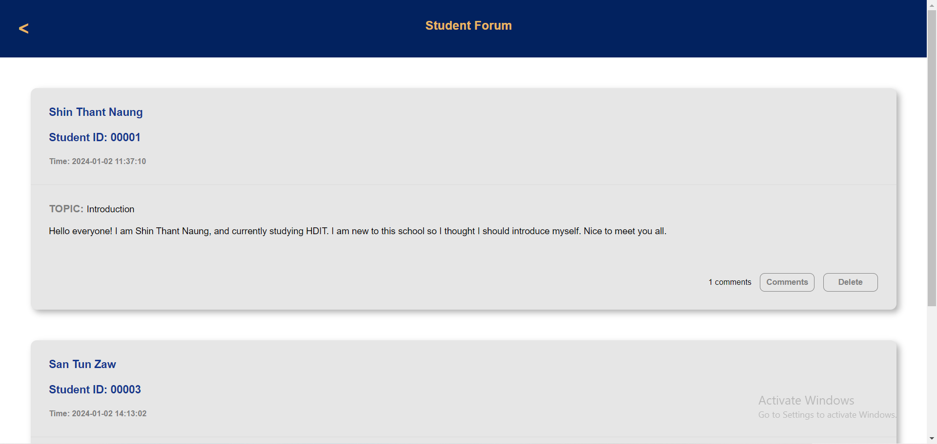

Click to delete post

Click to see comments of the post

Figure-17: Deleting student forum post

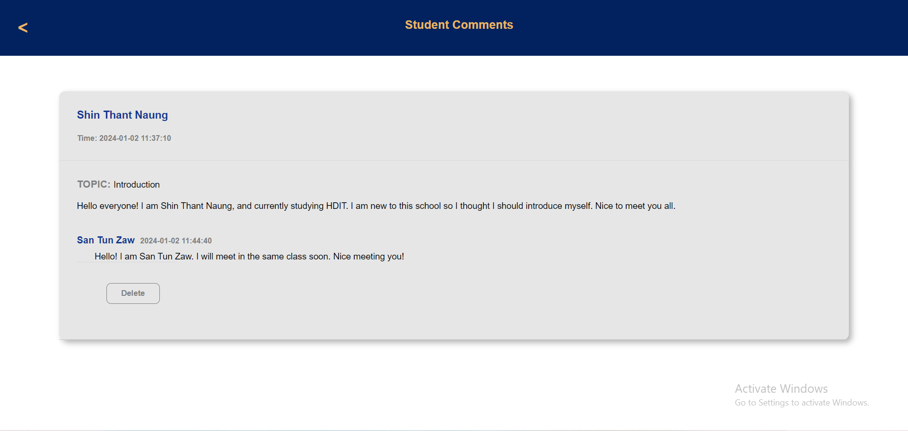

Click to delete comment

Figure-18: Deleting comment from the post

Only CEO of BUC can manipulate data of teachers and modules. CEO can insert new teacher or new module and can manage data such as editing and deleting.

1. First, select teacher or module according to what you want to insert.
2. Fill the fields and click “Insert” button to add data into the database.

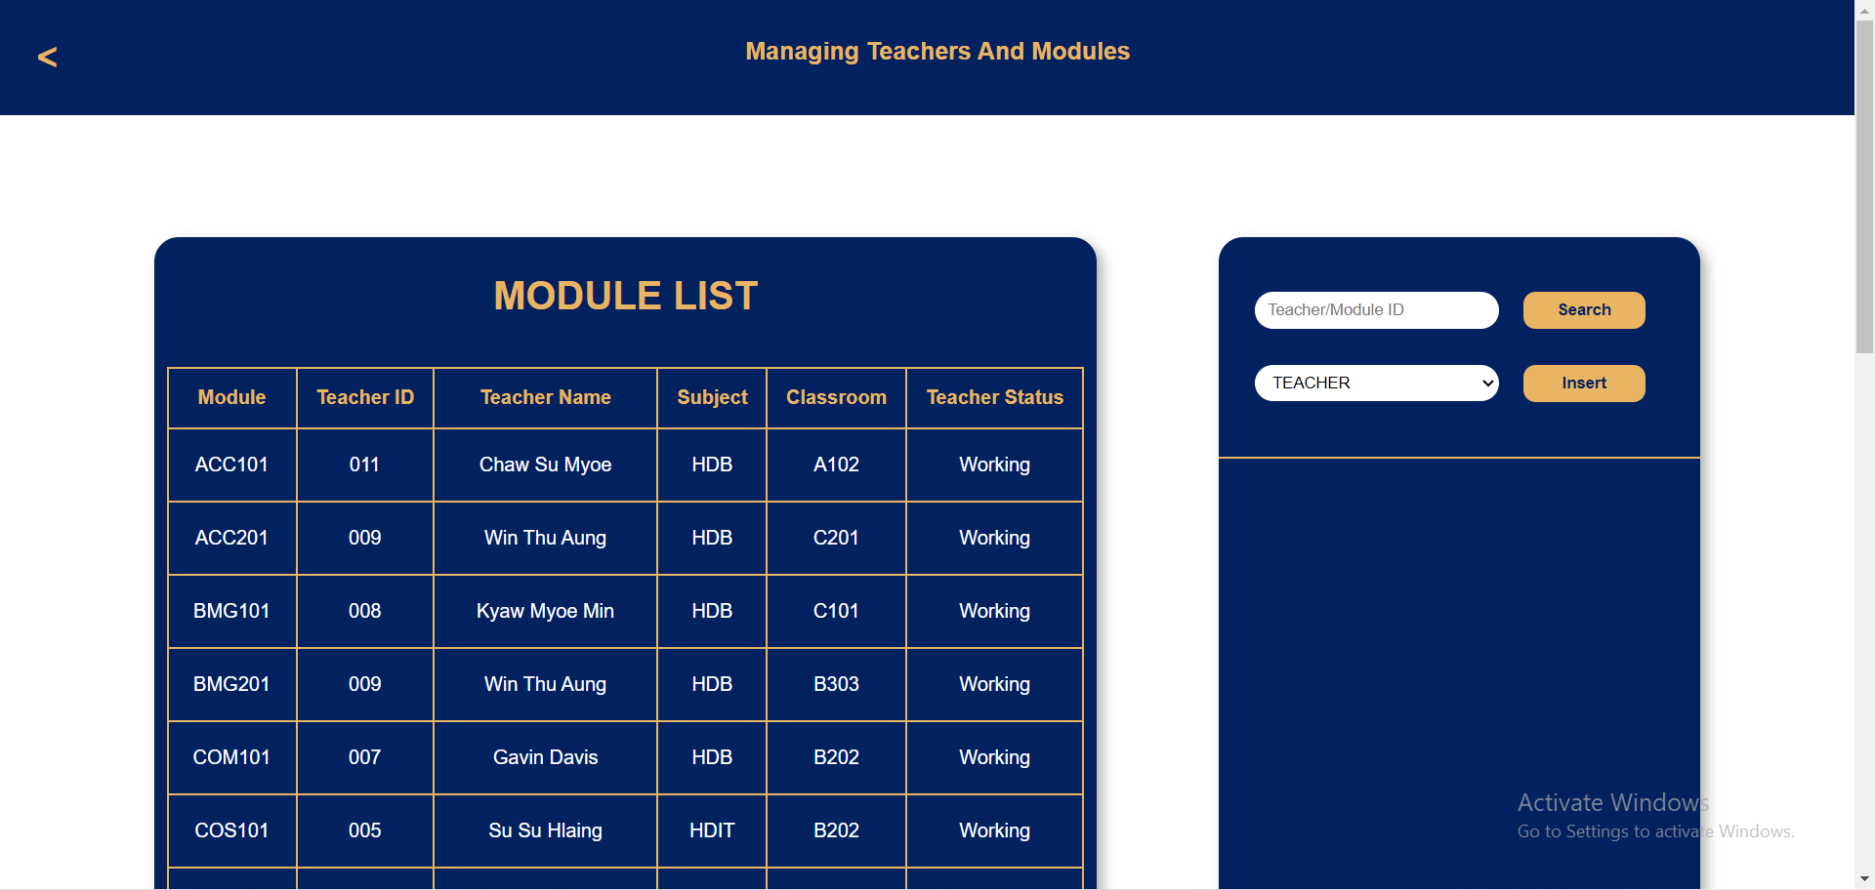

1

Figure-19: Selecting teacher of module

 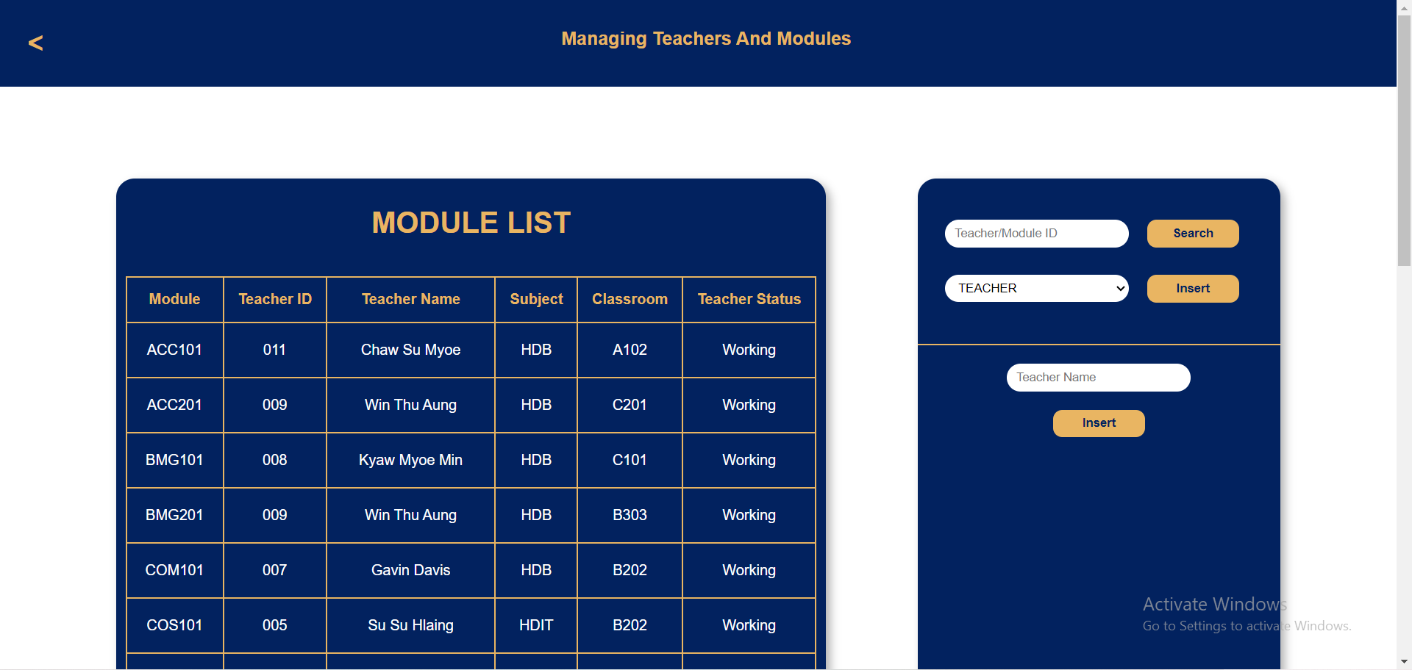 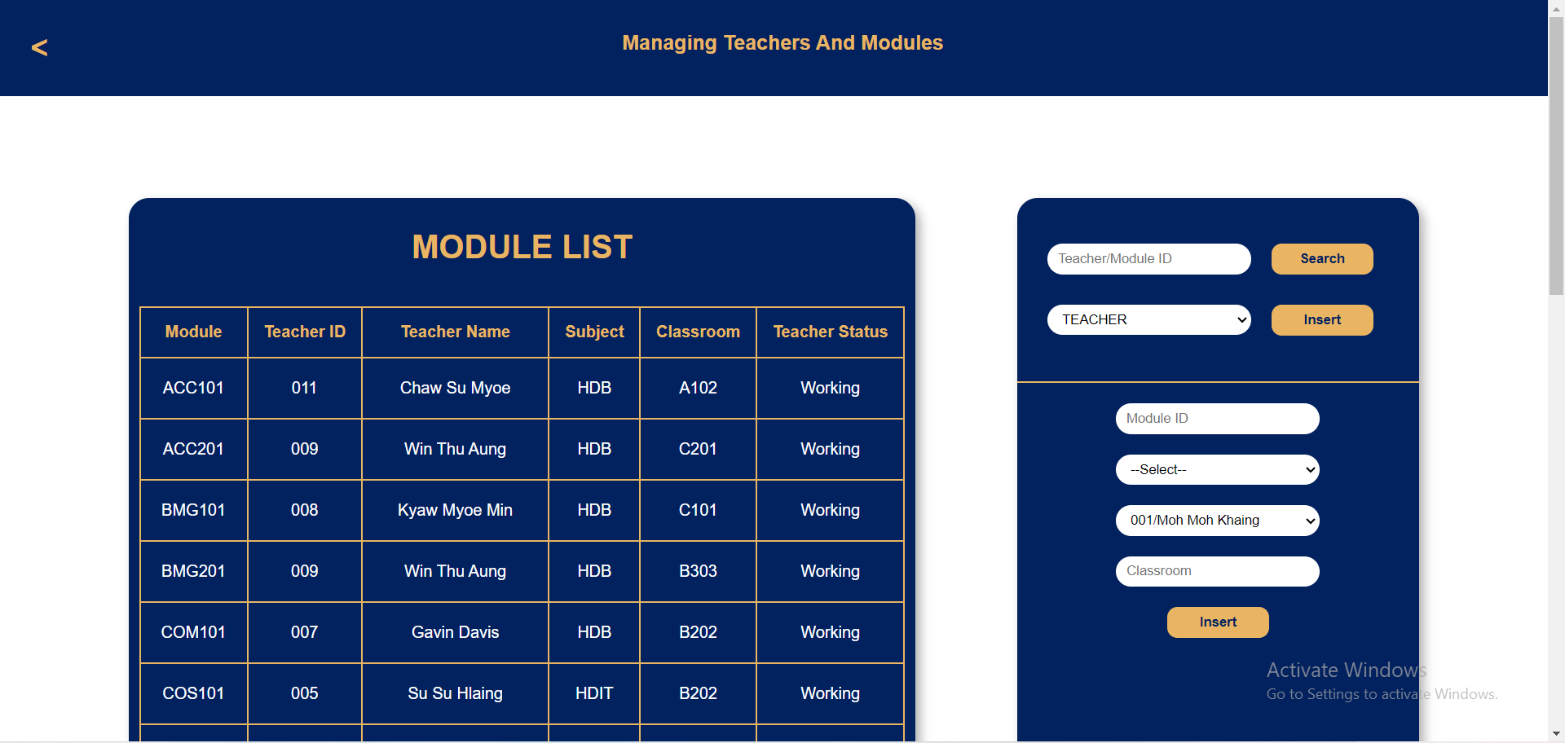

2

Figure-20: Inserting teacher data Figure-21: Inserting module data

1. Search teacher or module by ID.
2. Edit data in the form appear.
3. Click “Edit” to change teacher or module information.
4. Click “Delete” to resign a teacher or to delete a module.

 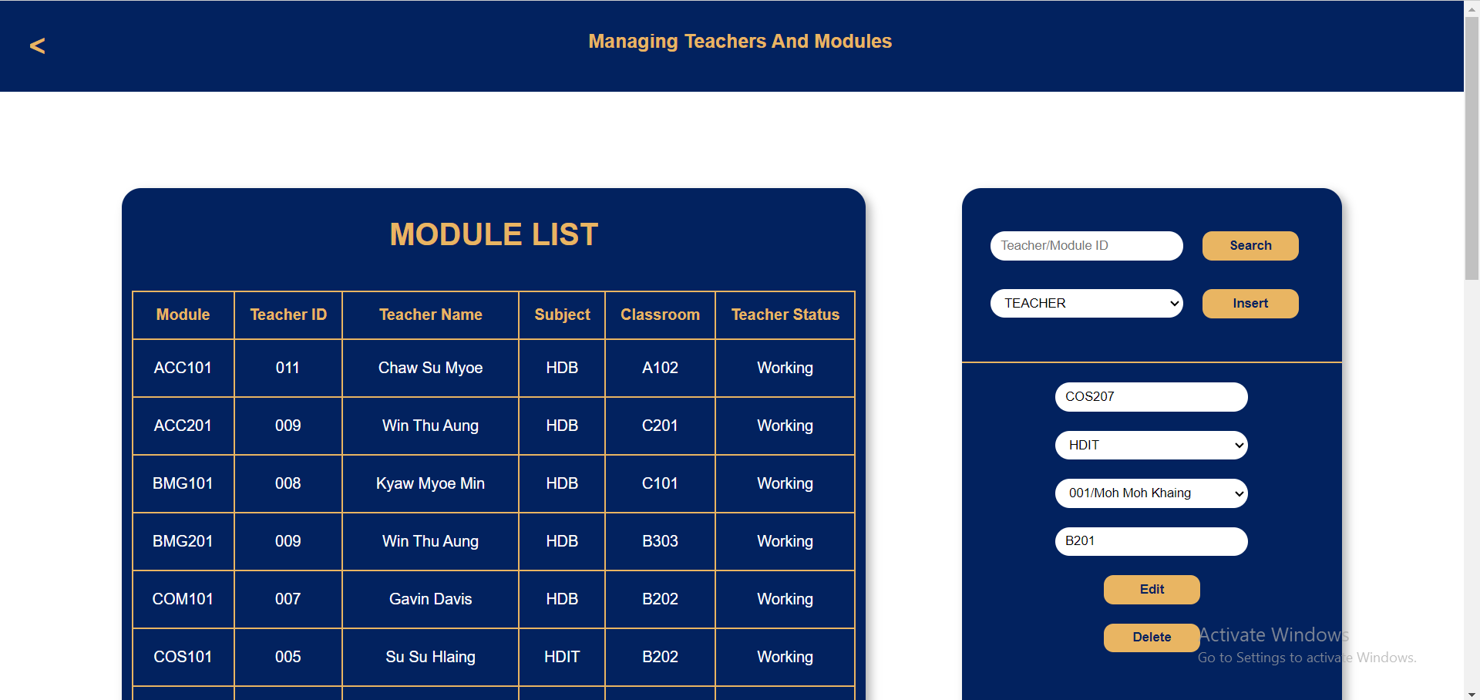 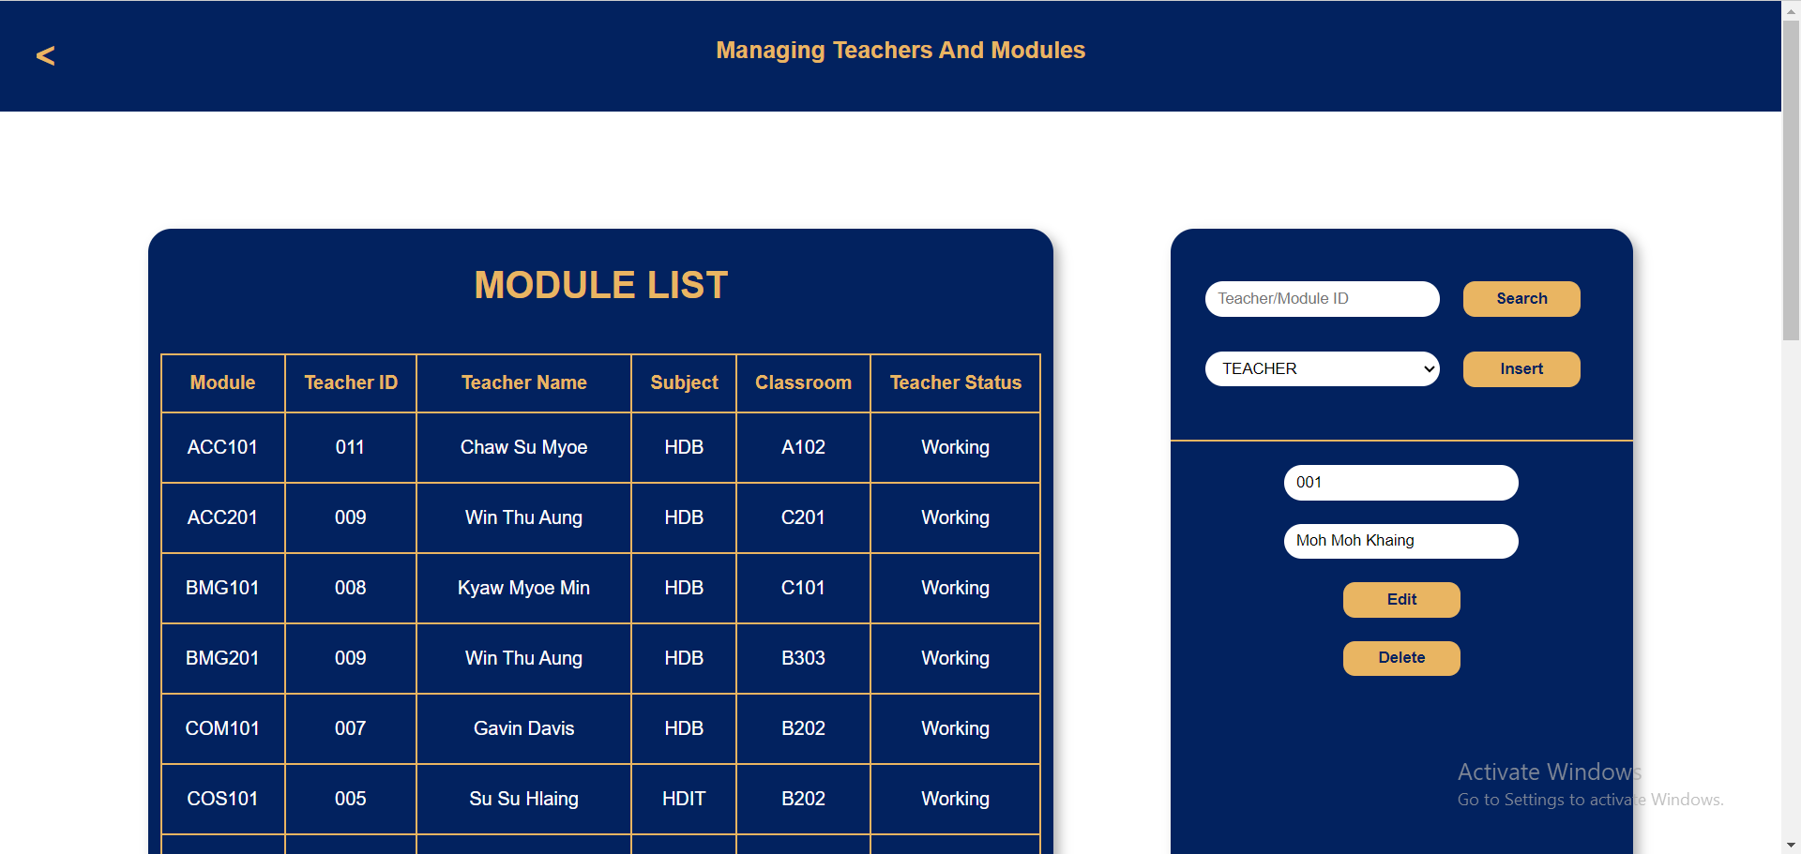

6

5

4

3

Figure-22: Manipulating teacher data Figure-23: Manipulating module data

Moreover, CEO is capable of adding a new employee, editing employee data or firing the employee.

1. Search admin you want to edit by ID.
2. The form will appear with searched admin’s information, and you can change as you like.
3. Click “Edit” to change the data also in database.
4. Click “Fire” to delete the employee from the database.

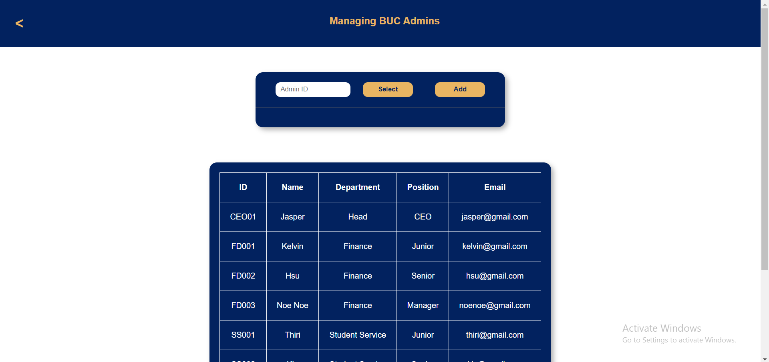

1

Figure-24: Searching employee by ID

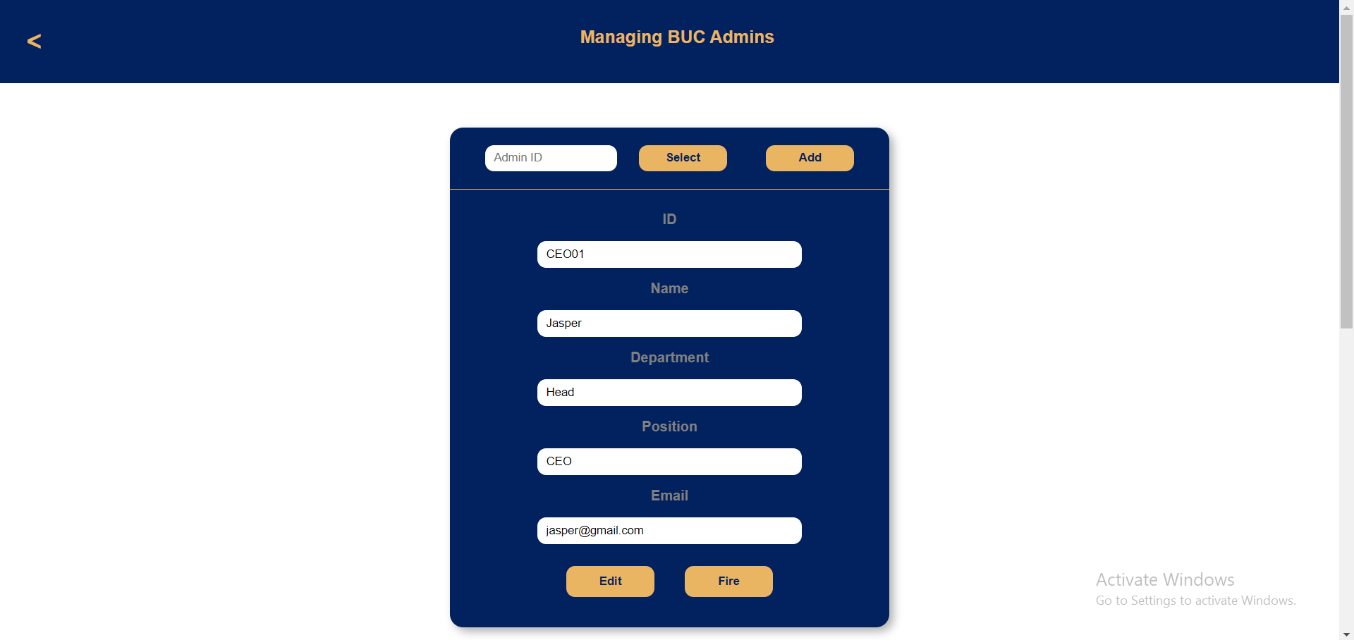

3

4

2

Figure-25: Editing or firing the employee

1. For adding a new employee, click “Add” button.
2. Fill the fields with new employee’s information.
3. Scroll down and click “Insert”.

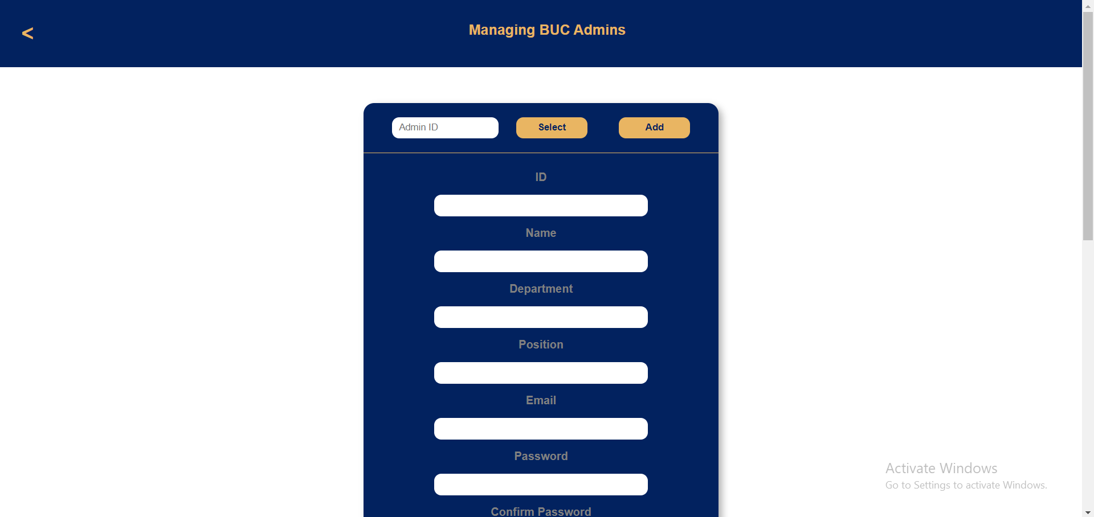

1

Figure-26: Getting the add form

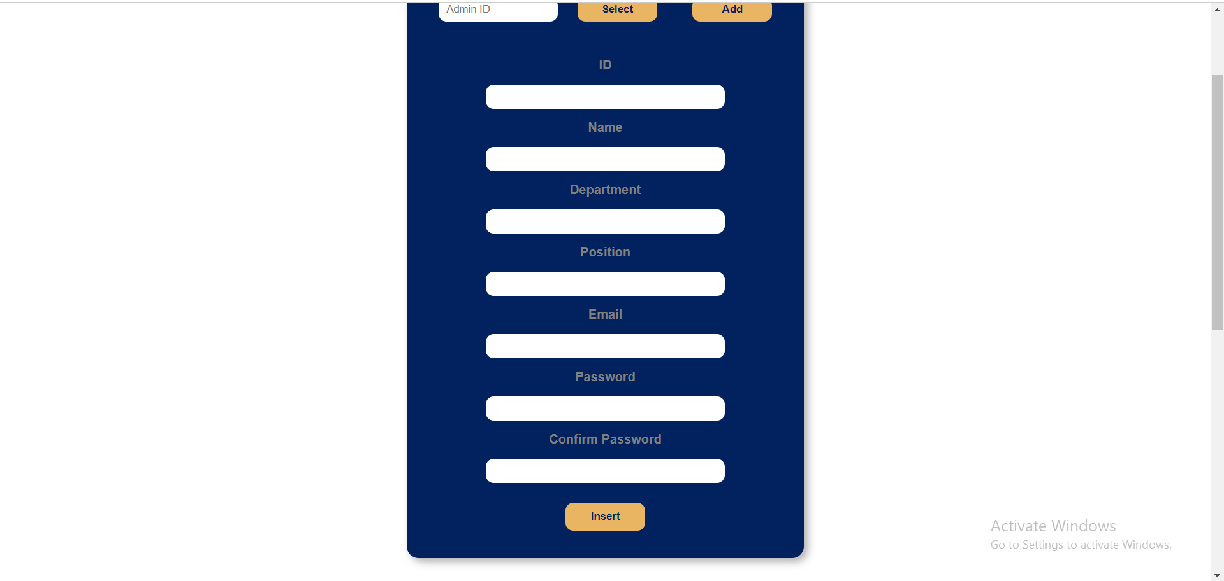

3

2

Figure-27: Filling form and inserting